3 Days Tarangire National Park, Ngorongoro Crater & Lake Manyara: Africa Natural Tours & Safari
AFRICA NATURAL TOURS & SAFARI (The best tour company in Tanzania)
Specialized in: Wildlife safaris, Cultural tourism, Mountain climbing and Beach holidays
Contact +255 764415889

Email-info@africanaturaltours.com
www.africanaturaltours.com

The Northern Circuit Encounter
Our three day Northern Circuit Encounter is a memorable experience of Northern Tanzania’s abundance of wildlife and spectacular scenery. Dubbed ‘Africa’s Garden of Eden’, The Ngorongoro Crater hosts an abundance of wildlife including the exceptionally rare black rhino and it is renowned for maximum game spotting. Exploring the vast plains of savannah in Tarangire National Park and tranquil game drives along the shallow waters of Lake Manyara will leave you feeling enchanted and revitalized.

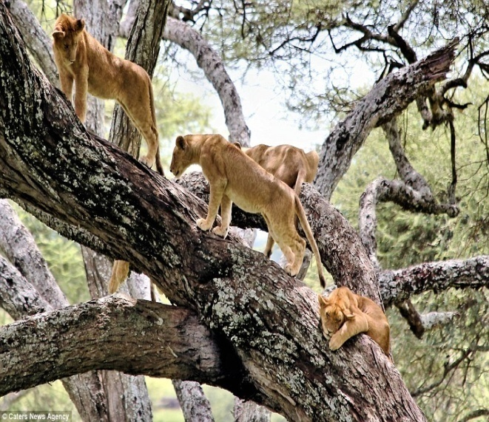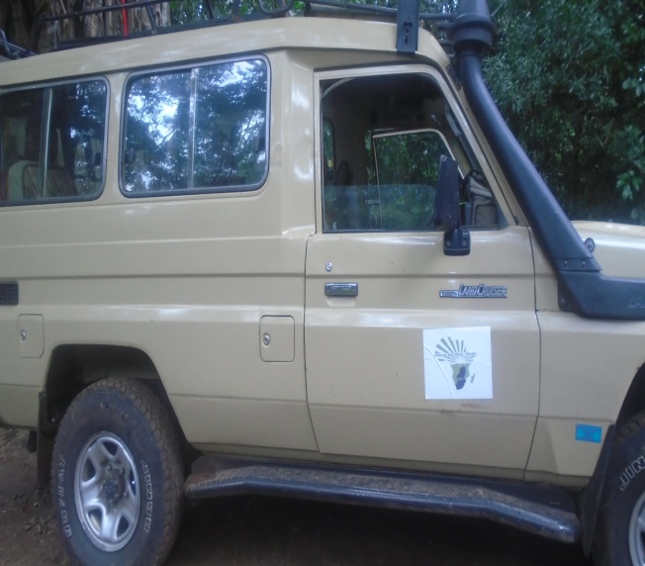

Day 0: Arrive at the Kilimanjaro International Airport

Arrive at the Kilimanjaro International Airport where you will be meet with Africa Natural Tours & Safaris driver at the airport and be transferred to the hotel in Arusha for overnight.

Day One: Arusha to Tarangire National Park

We will depart from Arusha in the early hours of the day and drive to Tarangire National Park where colossal termite mounds and ancient baobab trees await us. This park is renowned for their immense elephant population, their picturesque scenery and diverse bird life. Tarangire has an enticing wildlife that includes elephants, lions, giraffe, warthogs, ostriches, impalas, cheetah, mongoose, buffaloes and baboons. When our game drive comes to an end we will proceed to the Lake Manyara where you will get dinner and overnight.

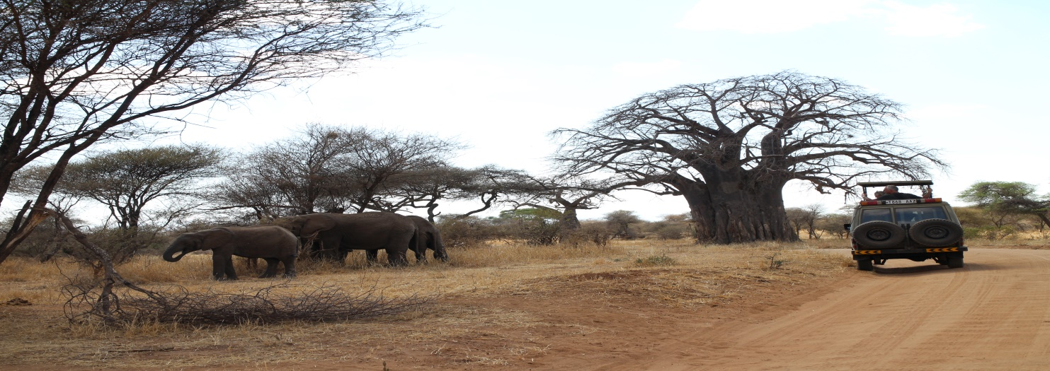
Main Accommodation
Accommodations: Clients selection Public campsite/ Tinted campsite/ Lodges
Meals: Water is included in all meals (Other drinks is not included)

Day Two: Ngorongoro Crater
We will have a timely start to the day to ensure that we arrive at the Ngorongoro Crater promptly – early morning game drives provide you with an excellent opportunity to spot wildlife. We will enjoy a wonderful game drive with an appetizing picnic lunch inside the crater. The elevated structure encourages the animals to settle inside the crater which means you are capable of spotting every member of ‘The Big 5’ in one day. The big five tend to dominate the savannah and consist of buffalo, lions, elephants, rhinos and leopards. The Ngorongoro Crater developed its structure nearly three million years ago when a colossal volcano erupted, making it the largest un-flooded, unbroken caldera in the world. You can also expect to encounter zebra, hippo, wildebeest and hyenas. You will find the flamingos gracefully lounging around the Soda Lake and the vultures are always corroding the discarded prey of a predator. Other birds include storks and geese. Your guide will be in close contact with the other safari drivers and his impressive ability to track down hidden animals will assure that you have an eventful day. We will have dinner and spend the night Lake Manyara.
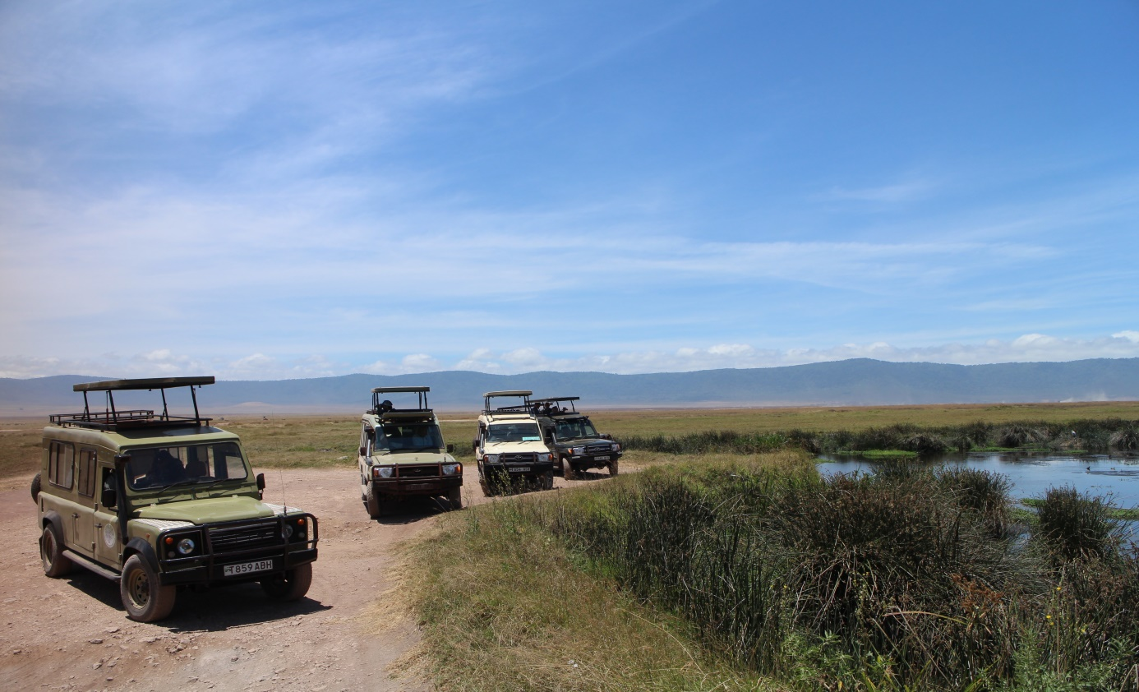

Main Accommodation
Accommodations: Clients selection Public campsite/ Tinted campsite/ Lodges
Meals: Water is included in all meals (Other drinks is not included)

Day Three: Lake Manyara to Arusha
In the morning we will depart to Lake Manyara where we will spend the day and enjoy a delectable picnic lunch. The park is nestled at the base of the rusty gold Great Rift Valley escarpment and the scenic landscape is breathtakingly magnificent. An abundance of species are able to reside in the park due to the wide range of habitats. The park record consists of over 380 species of birds, some of which are migratory, making it the ideal location for bird watchers. Thousands of pink-hued flamingos occupy the margin of the lake; other large water birds include pelicans, storks and cormorants. The wildlife you can expect to see are buffalo, elephants, giraffe, impalas and the ferocious hippos that inhabit the water. Our trip will come to an end in the late afternoon. We will proceed to Arusha.

Day of departure: Transfer to the Kilimanjaro Airport.

Package Includes
- Transport (4x4 Land Cruiser) with open roof
- Campsites / Lodge.
- park fees
- Tent
- mattress
- Professional English speaking safari guide & chef
- breakfast; lunches; dinner
- 1,5 bottle of water per day; tea and coffee with meals
- Pick up and drop off to Kilimanjaro International Airport.
- Pre and after Trek accommodations at the hotel, 2 nights at hotel in Arusha town with bed & breakfast (BB) Meal plan
- 18% VAT on tour fees & services which cost nearly 55% of the total cost charged.

Not Included
- Flights (International & Domestics)
- Travel insurance
- Visa cost which is $50 except for Canadian and USA passport holders which is 100$
- Personal items
- Tips for safari guide & chef
- Soda and Alcoholic beverages
- Extra activities (Balloon flight $600 per person & Masai Village $ 25 per person)

ABOUT OUR SAFARI VEHICLES

- It owned by Africa Natural Tours & Safaris Company Limited
- Want NO mileage or fuel limits
- High maintenance standards, we have our own maintenance shop.
- Both of our Safari Cars are New
- All of our cars are 4x4 with pop-top roofs
- All of our cars have refrigerator
- All of our safari cars have camera charging ports.
- Most of our Cars are air conditioned
- We provide Water during Safari.

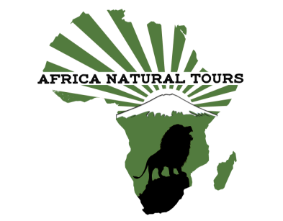

For more information visit www.africanaturaltours.com

