HIGHLIGHTS OF Albania 7 nights/8 days
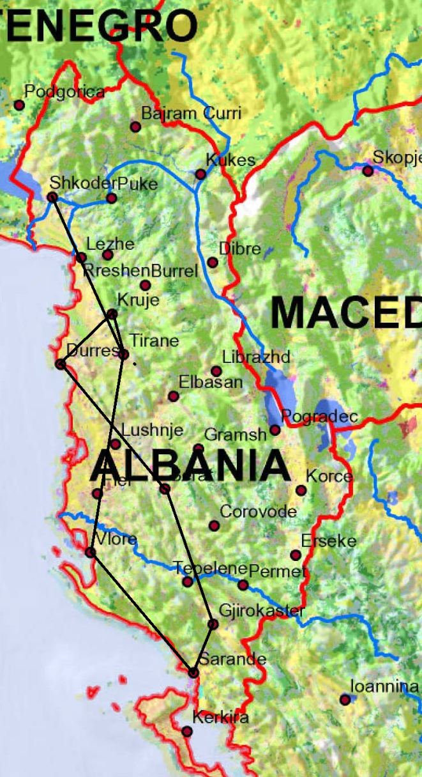

Day | Start | Tour | Overnight | Distance | Time
Day 1 | Airport |  | Tirana | 18 km | 20 min
Day 2 | Tirana | Shkoder-Kruje | Kruje | 176 km | 3.10 h
Day 3 | Tirana | Ardenice-Apolloni | Vlore | 160 km | 2.50 h
Day 4 | Vlore | Butrint | Saranda | 135 km | 2.00 h
Day 5 | Saranda | Blue Eye | Gjirokastra | 90 km | 1.00 h
Day 6 | Gjirokastra | Berat | Berat | 160 km | 2.40 h
Day 7 | Berat | Durres | Durres | 96 km | 1.35 h
Day 8 | Durres | Airport |  | 33 km | 40 min
Day 1: Airport – Tirana

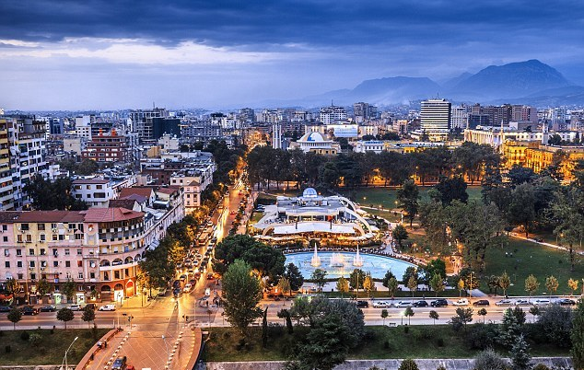

Meet at Tirana Airport by our representative. Transfer to the hotel in the heart of the city to freshen up afterwards a driven tour of the major city of Tirana.
Tirana is the capital and the largest city of the Republic of Albania. It was founded in 1614 by Sulejman Pasha and became Albania's capital city in 1920. The area now occupied by the city of Tirana has been populated since Paleolithic times dating back 30,000 to 10,000 years ago.

In Tirana we visit the famous mosque of Ethem Bey, Scanderbeg Square, Palace of Culture, Ministry Buildings.
In the evening, free to explore Blloku Area which used to be restricted zone in communist time, now is one of the trendiest area in Tirana.

Overnight in Tirana. Hotel “Tirana International”

WHAT TO VISIT: (entrance fees included)
THE STATUE OF GJERGJ KASTRIOTI “SKANDERBEG”
THE CENTER OF DEVELOPMENT OF CULTURE AND BUSSINES
THE PALACE OF CULTURE
THE MOSQUES OF HAXHI ET’HEM BEY
THE CLOCK TOWER

Day 2: Tirana – Shkodra – Kruja - Tirana

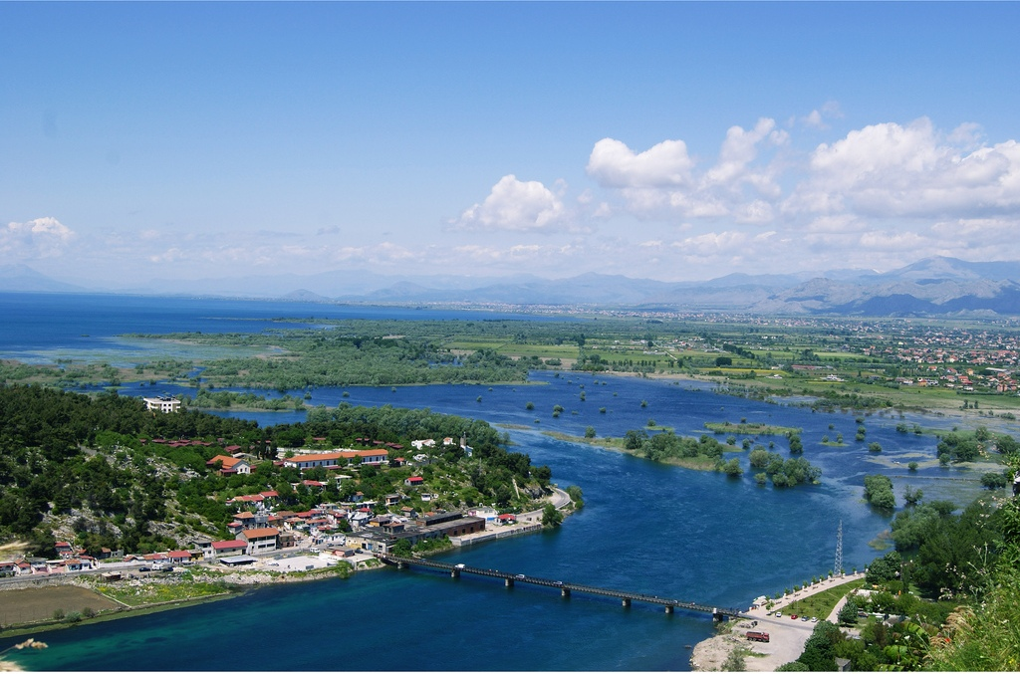

After breakfast we drive to Shkodra the most important town of north Albania and the Illyrian capital, in the 3rd century BC. Visit Rozafa Castle from where spectacular views all around can be admired. Experience the supremacy the Illyrians would have feel over their enemies standing in such an imposing castle. We will also visit the Marubi Photographic Museum with a selection of prints of negatives taken in starting from the second half of the 19th century till the 1900-s, illustrating the life of the population of the area in that period. Take a walk in the newly renovated pedestrian area of Italian and Austrian architecture, testimony to this town historic links with both these countries.
Proceed to Kruja - the town of our national hero Scanderbeg. We visit the Skanderbeg Museum, a very rich Ethnographic Museum and the Old Bazaar where the best handmade souvenirs can be purchased.
Overnight in Kruja.

WHAT TO VISIT: (entrance fees included)
ROZAFA CASTLE
MARUBI MUSEUM
ROMAN CATHOLIC CATHEDRAL

THE FORTRESS MUSEUM OF GJERGJ KASTRIOT “SKANDERBEG”
THE ETHNOGRAPHIC MUSEUM
OLD BAZAAR

Day 3: Tirana – Ardenice – Apolloni - Vlore

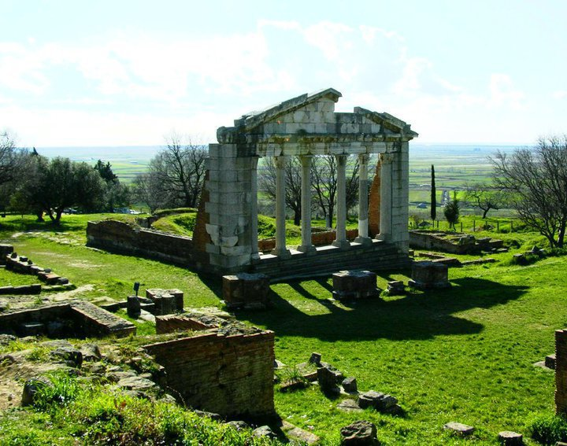

After breakfast, depart for Vlora. On the way we stop at the Monastery of Ardenica, supposed to have been built in the middle ages, as argued by a stone in entrance dating back to the 1417. However the first building belongs to the beginning of XVIII century. Today inside the church you can admire icon paintings of 1743-1745, by Albanian artists such as Konstandin and Athanos Zografi, as well as Konstandin Shpataraku.
Proceed to the ancient city of Apollonia situated on the famous Via Egnatia - one of the most important cities in Roman times. The Roman Emperor Augustus Octavian studied here. Afterwards we continue to Vlora where we visit the Independence Museum, situated in the original house where the first Independent Albanian Government had its offices.
Afternoon & evening at leisure.
Overnight in Vlora.

WHAT TO VISIT: (entrance fees included)
MONASTERY OF ARDENICA
THE MUSEUM OF APOLLONIA
THE EXCAVATION AND THE MONUMENTS OF APOLLONIA
INDEPENDENCE MUSEUM IN VLORA

Day 4: Vlore – Butrint (UNESCO) – Saranda

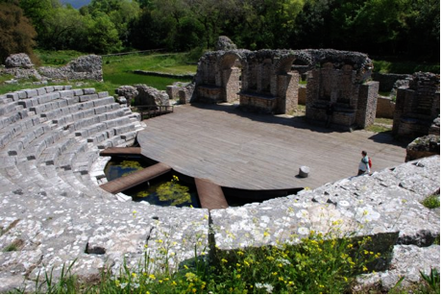

After breakfast we drive to Saranda on the spectacular Albanian Riviera looking down at the Ionian Sea. Breathtaking sceneries await us at the Llogara pass - 1000 m above sea level.

After we continue to Butrint. Visit of UNESCO World Heritage Site of Butrinti. It’s one of the most important archaeological sites in the country containing different artifacts and structures which date from the Bronze Age up until the 19th century. A number of major monuments are still extant including the city walls, late-antique baptistery, great basilica, and theatre and Venetian castles. After the visit, turn back to Saranda.

In the afternoon visit at the Lekursi castle with a beautiful view of the bay of Saranda and Corfu island.
Afternoon free to explore Saranda.
Overnight in Saranda.

WHAT TO VISIT: (entrance fees included)
ROMAN AMPHITHEATRE
ARCHAEOLOGICAL MUSEUM
LEKURSI CASTLE

Day 5: Saranda – Blue Eye spring – Gjirokastra (UNESCO)

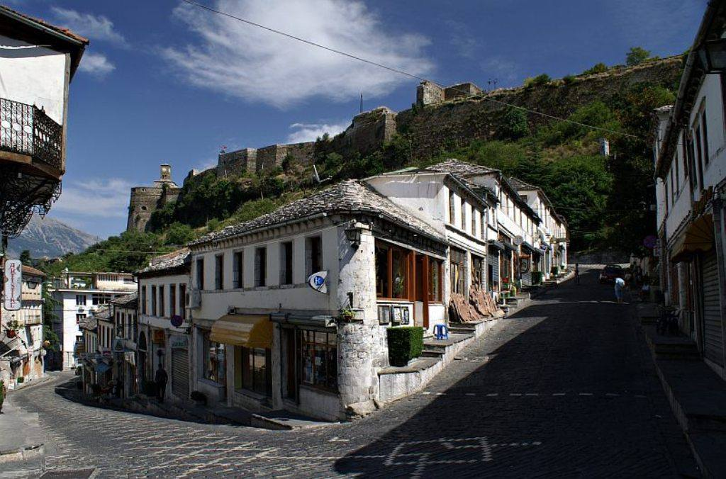

After breakfast we drive to Gjirokastra a UNESCO site and museum town with beautiful and very distinct architecture.
On the way to Gjirokastra we stop for a visit at the blue eye spring.
After arrival in Gjirokastra we visit the Fortress which is used as the venue for the National Festival of Folk Song and Dance and has an Arms’ Museum with weapons from WWII. Next we visit the Ethnographic Museum which is also the house where the Albanian dictator was born in. We depart for Berat one of the most attractive characteristic towns in Albania and a UNESCO protected site.

In the afternoon explore the city of Gjirokastra independently.

Overnight in Gjirokastra.

WHAT TO VISIT: (entrance fees included)
BLUE EYE SPRING
THE CASTLE
THE WEAPON MUSEUM
THE ENVER HOXHA BIRTH HOUSE (ethnographic museum)

Day 6: Gjirokastra (UNESCO) - Berat (UNESCO)

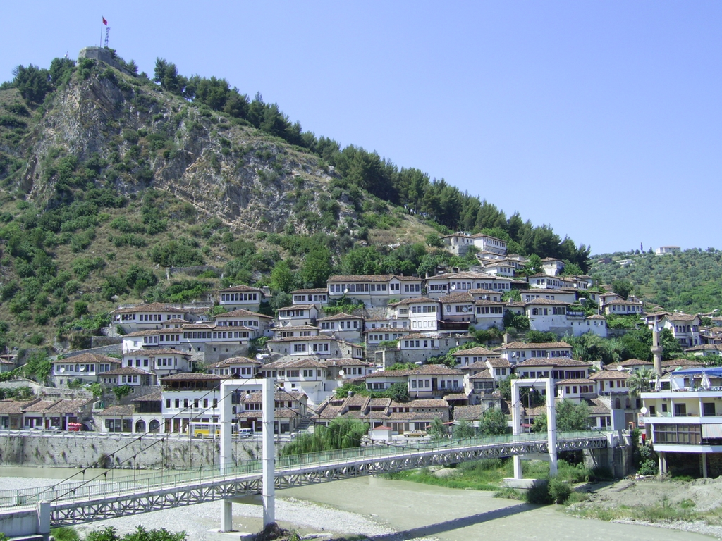

After breakfast we depart for Berat where we visit the Castle and the Onufri Museum. Berat castle is of particular interest as people still live within its walls in their traditional houses, as have their ancestors for centuries. The castle used to have over many churches of which 7 still remain, including one turned into Onufri Museum. Onufri was an Albanian Icon master painter of the 16th century who painted many orthodox churches in Albania and Greece.

After this interesting experience free to explore the old city.

Overnight in Berat.

WHAT TO VISIT: (entrance fees included)
THE FORTRES
THE ONUFRI’s MUSEUM

Day 7: Berat (Unesco) – Durres

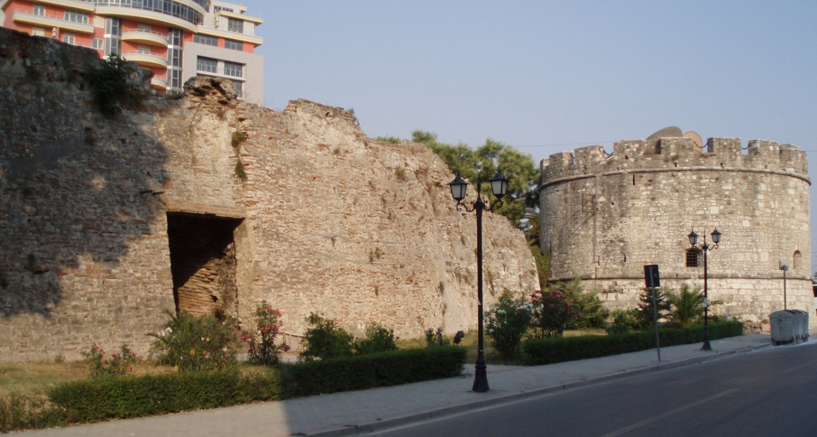

After breakfast we depart for Durres one of the oldest (founded in 627 B.C.) and most important cities in Albania where we have lunch (optional). After lunch we take a sightseeing tour of the Amphitheatre situated in the middle of the modern city in an inhabited area, and the Archaeological museum rich in artifacts found in the city and its suburbs.

Overnight in Durres.

WHAT TO VISIT: (entrance fees included)
AMPHITHEATRE
ARCHAEOLOGICAL MUSEUM

Day 8: Durres – Airport

After breakfast, free to explore until time of transfer to Airport. End of our services.

Price (August):
15-20 pax: 370 E/per person in double/twin room (Tour leader free of charge)
21-25 pax : 330 E/per person in double/twin room (Tour leader free of charge)

Single Supplement: 70E/per person

Price (September):
15-20 pax: 350 E/per person in double/twin room (Tour leader free of charge)
21-25 pax : 310 E/per person in double/twin room (Tour leader free of charge)

Single Supplement: 80E/per person

Including:

Transport in very good A/C bus
Turkish speaking guide in Albania
Accommodation at 3-4 * hotels with breakfast.
All taxes
Tickets in all monuments as per program.

Not included:

Lunches & Dinners
Everything that is not specified in the "Including

