Circle around Mt. Manaslu 8th highest Mountain in the world. Experience the intermingle of Tibetan culture with local Gurung tribes while trekking in the Manaslu circuit. 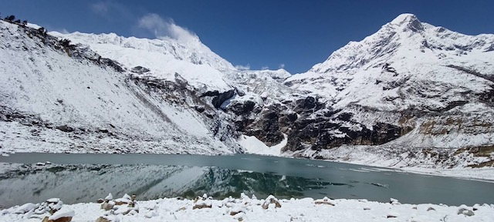

**Places to visit while in Manaslu Circuit Trek.**

**Kal Tal, meaning 'Death Lake' (3600m.):** Detour to Kal Tal is 4 hours of walking above the Prok village. This is a scenic place to view the diverse landscape and is religiously significant.

**Hang Gompa and Himalchuli Base Camp (4020m):** It is a beautiful monastery from Bihi. Walk for about one hour and reached the monastery in the meadows of pine forest.

**Phungen Gompa (Around 4050m/11316ft.):** You may take a detour from Shyalla or Sama Gaon. This is the most scenic and picturesque place at the Manaslu Base Camp.

**Birendra Tal (3450m/ 11316ft.):** This is a high-altitude freshwater turquoise lake feed by glaciers. It is one hours walk from Sama Gaon. You may try to swim or wash your feet.

**Manaslu Base Camp (4900m/16072ft.):** The base for the Manaslu expedition patch their tent and stays for acclimatization. It is 4 hours' walk from Sama Gaon into the steep slope. The views are extraordinary of the lake, glacier, landscape, and vegetation.

**Manaslu Circuit Trek Highlights**

• The jaw-dropping natural beauty of forests, rivers, waterfalls and flora and fauna of the Manaslu region.

• Friendly local people with the rich culture of the area including Nepalese and Tibetan ethnic groups.

• Circle around the shadows of Manaslu within 14 days

• Mesmerizing views of Manaslu, Cheo Himal, Himlung Himal, Nemjung, Gyaji Kang and Kang Guru, and Annapurna II.

**Here is the day-to-day outline itinerary sending you for viewing and waiting for your feedback.**

**Day 01:**

Arrival and transfer to Hotel in Kathmandu (1,350 m)

**Day 02:**

Trek preparation day and last minutes shopping in Kathmandu

**Day 03:**

Kathmandu to Machhakhola (900 m)/8hrs bus drive

Today we take a long drive to Macchekhola. Along the way, you will see many beautiful greenery landscapes, rivers, and beautiful views of the Ganesh Himal and Manaslu mountain ranges. Beautiful rivers local villages, Waterfalls, and rice fields make your drive more exciting. Arrival and check-in guesthouse.

Distance cover: 160 km, Approx. time taken: 8 hours

**Day 04:**

Trek to Jagat (1,350 m), 22 km/6 hours

Machekhola Trek to Jagat (1,350 m), 22 km/6 hours

This is the narrow exposed trail and needs to Cross the Macchakhola which is known as a fish- steam. This is the small settlement of the Gurung, Magar, and Chhetri people. There are many scrambling up and down slopes. And you will reach the Tatopani(natural hot spring). After the short walk to the forest, cross the river over the suspension bridge and walk uphill to Jagat overnight.

Approx. time taken: 6 hours

Distance cover: 22km/ 13.66 mi

**Day 05:**

Trek to Deng 1,850 m/ 19 km/6-8 hours

The first section is easy going walk and crosses the Budhi Gandaki, the trail ascends through the rice terrace up to Philim. This is quite a big Gurung settlement and beautiful people. Once you cross the village, the route enters the uninhabited gorge. Cross the Budi Gandaki over the wooden cantilever bridge. Then the trail makes its way up to the western side and valley offering a pleasant walk through the bamboo forest to Deng Khola once you cross the Khola, we reach Deng village overnight at Deng.

Distance cover: 19km, Approx. time taken: 6-7 hours

**Day 06:**

Trek to Namrung 2,650 m/ 17 km/7 hours

Deng Trek to Namrung 2,650 m/ 17 km/7 hours

After a short walk, the trail crosses the Budi Gandaki. There is a shop where you can buy some drinks. The trail darts in and out of two ravines then continues to climb high above steep on the opposite side of the river then cross the Budi Gandaki here. we cross the Budi Gandaki several times today and come across several Gomba and Mani stone routes. The trail follows the river upstream through a dense forest followed by a steep climb to Namrung.

Distance cover: 17 km, Approx. time taken: 7 hours

**Day 07:**

Trek to Lho 3,150 m/ 11 km/4 hours.

Now, the trail enters the Nupri region. The people of this region are all descendants of Tibetan immigrants. Most of them put on Chubas dress, they are known as Bhote people. Today, you can enjoy walking through the rhododendron, firs, and oak forest. Spectacular views of Manaslu (8,156 m) and Manaslu North (7,154 m). The trail then climbs small steam and gets to Lho, a big village with Monastery, gumba, and Mani stone.

Distance Cover: 10.5 km, Approx. time taken: 5 hours

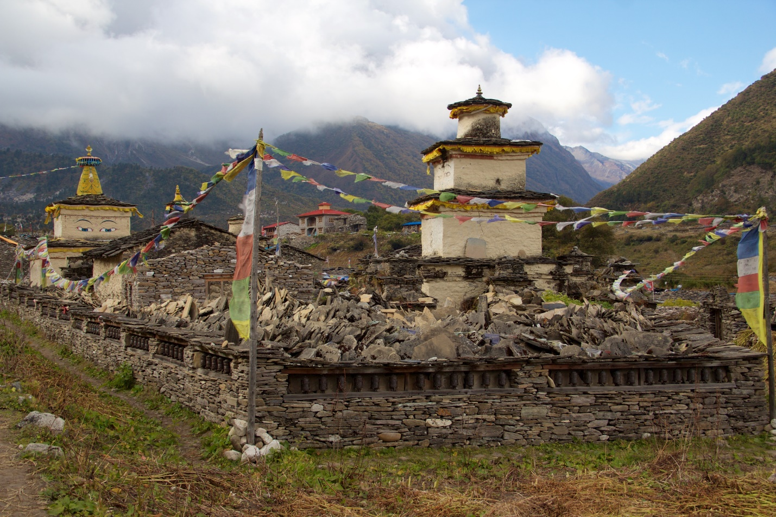

**Day 08:**

Trek to Sama Gaon 3,500 m/ 8 km/4 hours

We need to cross the ridge out of the valley to the BudhiGandaki side, and trek in and out through the rock-strewn moraine. We climb steadily and pass through forests and reach Lihi, a wonderful village with many Mani Stones, Chortens, and barley terraces. The trail drops and crosses the side valley of Simnang Himal with Ganesh Himal always close by. We further pass through Sho, Lho, and Shyala villages before reaching Sama Village. We can enjoy breathtaking views of Mt. Manaslu from Lho village and also can explore the very popular Ribung Gompa. Shyala village will be surrounded by high mountains like Himal Chuli and Peak 29 (Ngadi Chuli) to the left and other snow summits to the right, and at the far end stands Ganesh Himal. This will be a pleasant stay at Sama Gaon.

Distance cover: 17km, Approx. time taken: 6 hours

**Day 09:**

Acclimatization day

This is the acclimatization day, it is a very beautiful day as Sama Gaou is one of the most spectacular villages. You have a couple of options to explore around. South of Sama Gaon, there is an old Pung-Gyen gompa, which is hidden behind the ridge in front of Manaslu. This is the best viewpoint for the beautiful landscape and surroundings. You take a rest to acclimatize and relax. In addition one can hike to the beautiful glacial Lake 'Birendra Lake' or Manaslu Base Camp for excellent views of Samdo (Pangphuchuli), Nagdi Chuli, Simnang Himal, Manaslu glacier, and Manaslu icefall. Itself, this is the heavenly paradise environment.

Option for detour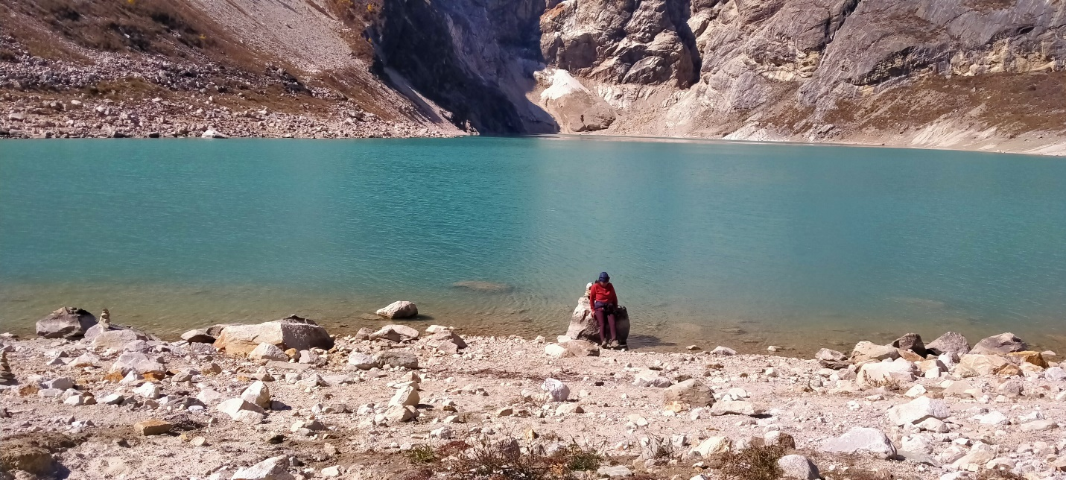

Opt I: Trek Pungen Gompa and back-14 km, altitude gain 550m, walking 6 hours

Opt II: Birendra Tal and back-5km, 2 hrs

Opt II: Trek to Manaslu base camp and back-17km/8hrs altitude gain-900m

**Day 10:**

Trek to Samdo 3,700 m/9 km/4 hours

Trek to Samdo village is another pleasant day. The path is wide and properly managed. Passing the pine forest and Mani wall, the view of the landscape and Manaslu ranges and Buddha Himal, Shringi Himal are most eye-catching. After crossing the river through wooden bridge leads you to Samdo.

Distance cover: 17 km, Approx. time taken: 4 hours

**Day 11:**

Trek to Dharamsala 4,450 m/6 km/4 hours

After acclimatization day in Samagaun, people are more excited about the Larkya pass. Today, we descend on a wide gentle path and enjoy the big old mani stone wall and Chorten. Upon crossing two streams and witnessing the Larkya Glacier we go around the valley of the Salka Khola and climb up again to the Dharmasala. Along the way passing Larke Bazaar "fair seasonal Tibetan market" is another interesting place to explore.

Distance cover: 12 km, Approx. Time taken: 5 hours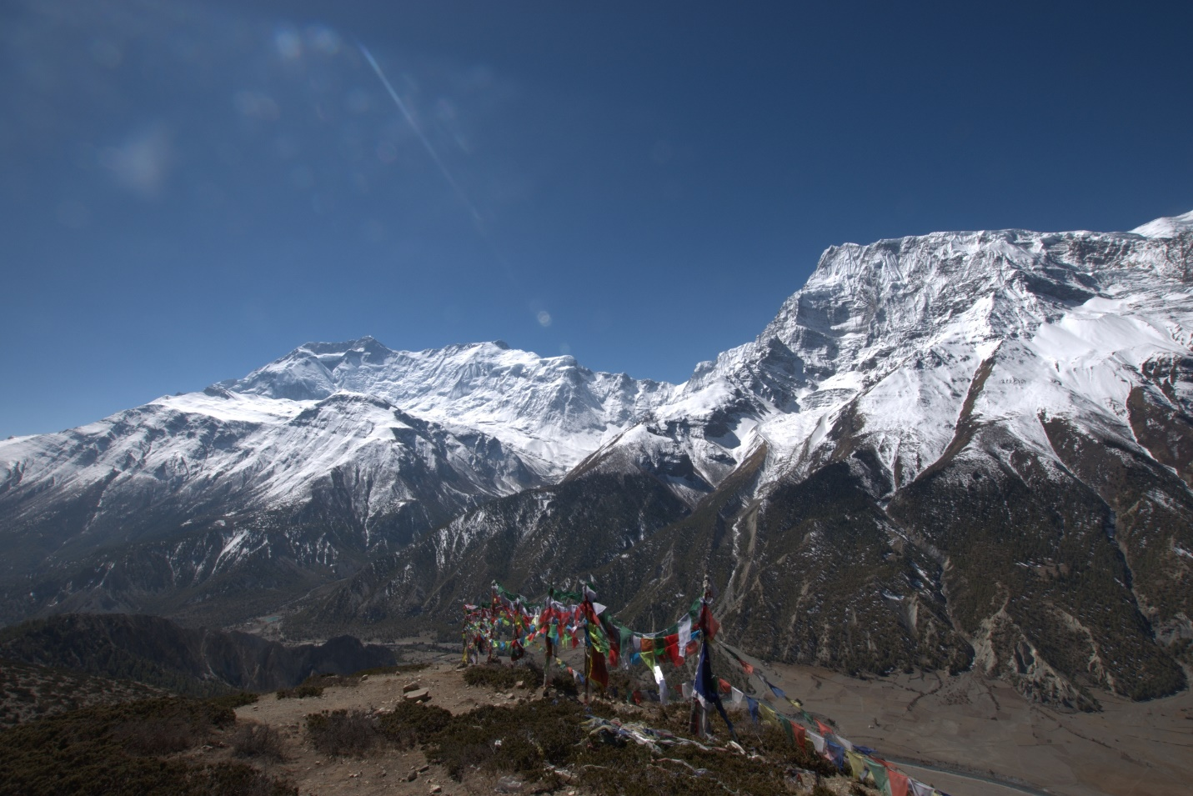

**Day 12:**

Trek to Bimtang (3,600 m) crossing Larkya La (5,106 m)/16 km/7,8 hours

Today is the main day as you are going to cross the Larke al pass (5,160 m), which is one of the most beautiful and tremendous. The route is long and gentle climbing beside the moraine. The Larkya Glacier offers great views of Cheo Himal (6,820 m), Gyaji Kung, Kang Guru (6,981 m), Annapurna range, and Larkya Peak. Now, we descend along the top of a moraine, down steep scree slopes. Ahead walk through grassy moraine and a big Mani stone that leads to a large meadow. Finally, you will be in Bimtang where you can have a big night after the successful pass.

Distance cover: 24 km, Approx. time taken: 8 hours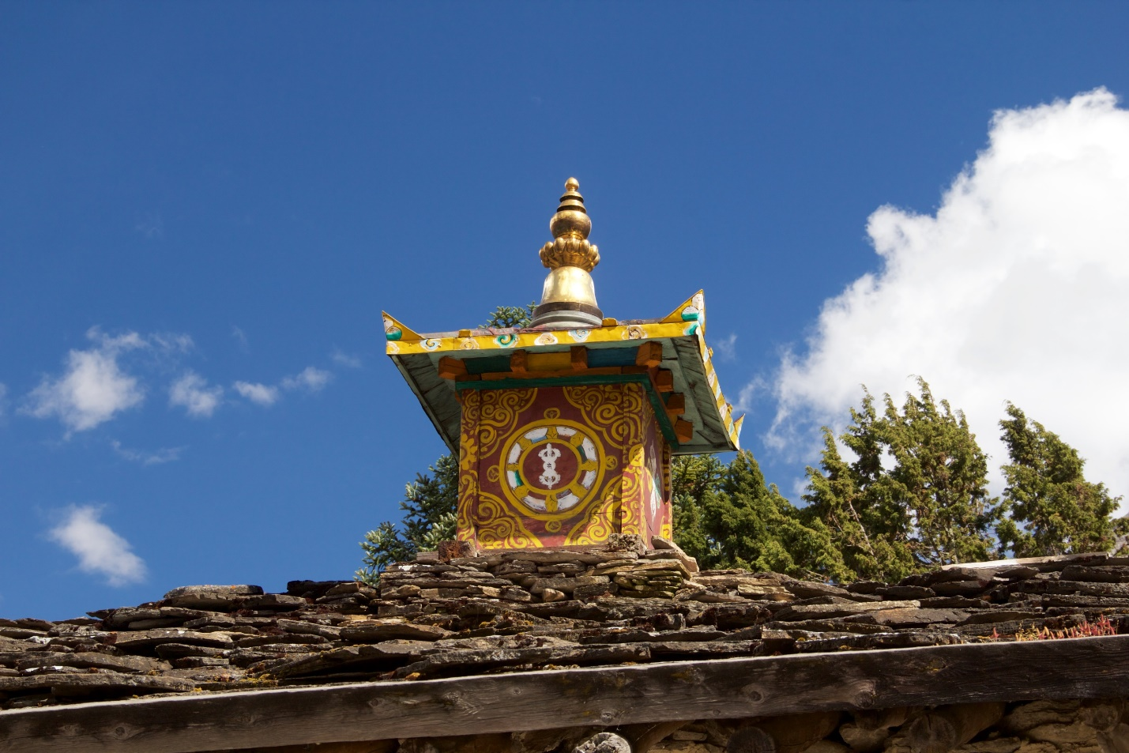

**Day 13:**

Trek to Tilje 5/6hrs/17km

Walk through the forest and waterfall to Tilje, this is a pleasure walking until Tilje through the pine and rhododendron forest.

Distance cover: 15 km, Approx. Time taken: 6 hours

**Day 14:**

Trek to Dharapani where you will have lunch and trek to Tal. 5hrs.

Dharapani is the world-famous Annapurna Circuit trek and Manaslu Circuit junction. starting point of Annapurna circuit. Today is easy and walk but picturesque. Arrival and check in hotel in Tal.

Distance cover: 10 km, Approx. Time taken: 5 hours

**Day 15**

Tal to Beshisahar by local sharing jeep and then Bus to Kathmandu 170 km, 6 hours.

**Day 16: Final departure**

After having the breakfast at hotel we drop you at Kathmandu International Airport for your onward flight to home.

**Our package includes the following services.**

* Airport picks up and drops off by private vehicle
* Manaslu Conservation entry permit (MCAP)
* Annapurna Conservation Area Permit (ACAP)
* Manaslu Restricted Area Permits for 7 days
* Trekker Information Management System (TIMS)
* All ground transportation as per itinerary by public and private sharing vehicle
* 12-night overnight Tea house Accommodation during the trek as per itinerary
* 3-Night hotel accommodation in Kathmandu (Twin Sharing) including breakfast
* Full board meals (Breakfast, Lunch, and Dinner) whilst trek
* Sleeping bag and down jacket if required
* Government-certified, well-experienced English Speaking trekking guide
* Salary including insurance, equipment, accommodation and food for all Nepalese Guide

**The below items are not included in our package**.

* International flights to and from Nepal
* Nepal Entry Visa fees, Visa can obtain at Kathmandu International Airport on arrival
* Entry fees or donations, museums, monasteries while on trekking  etc
* Emergency evacuation by Helicopter just for incase, the cost should be bear by your travel insurance company.
* Extra night hotel and food in Kathmandu in case of early return from the mountain than a scheduled plan.
* Alternative transportation in case of heavy rain, landslide, strike, road blockade, etc.
* Meals other than those listed in inclusions (Hot and cold, alcoholic and non-alcoholic drinks)
* Laundry, towels, hot showers, internet access, recharging of batteries and other items of a personal nature.
* Tips for guides

**Trek Type: Private trip**

**The cost of the above-mentioned services is-----1099 USD per person.**