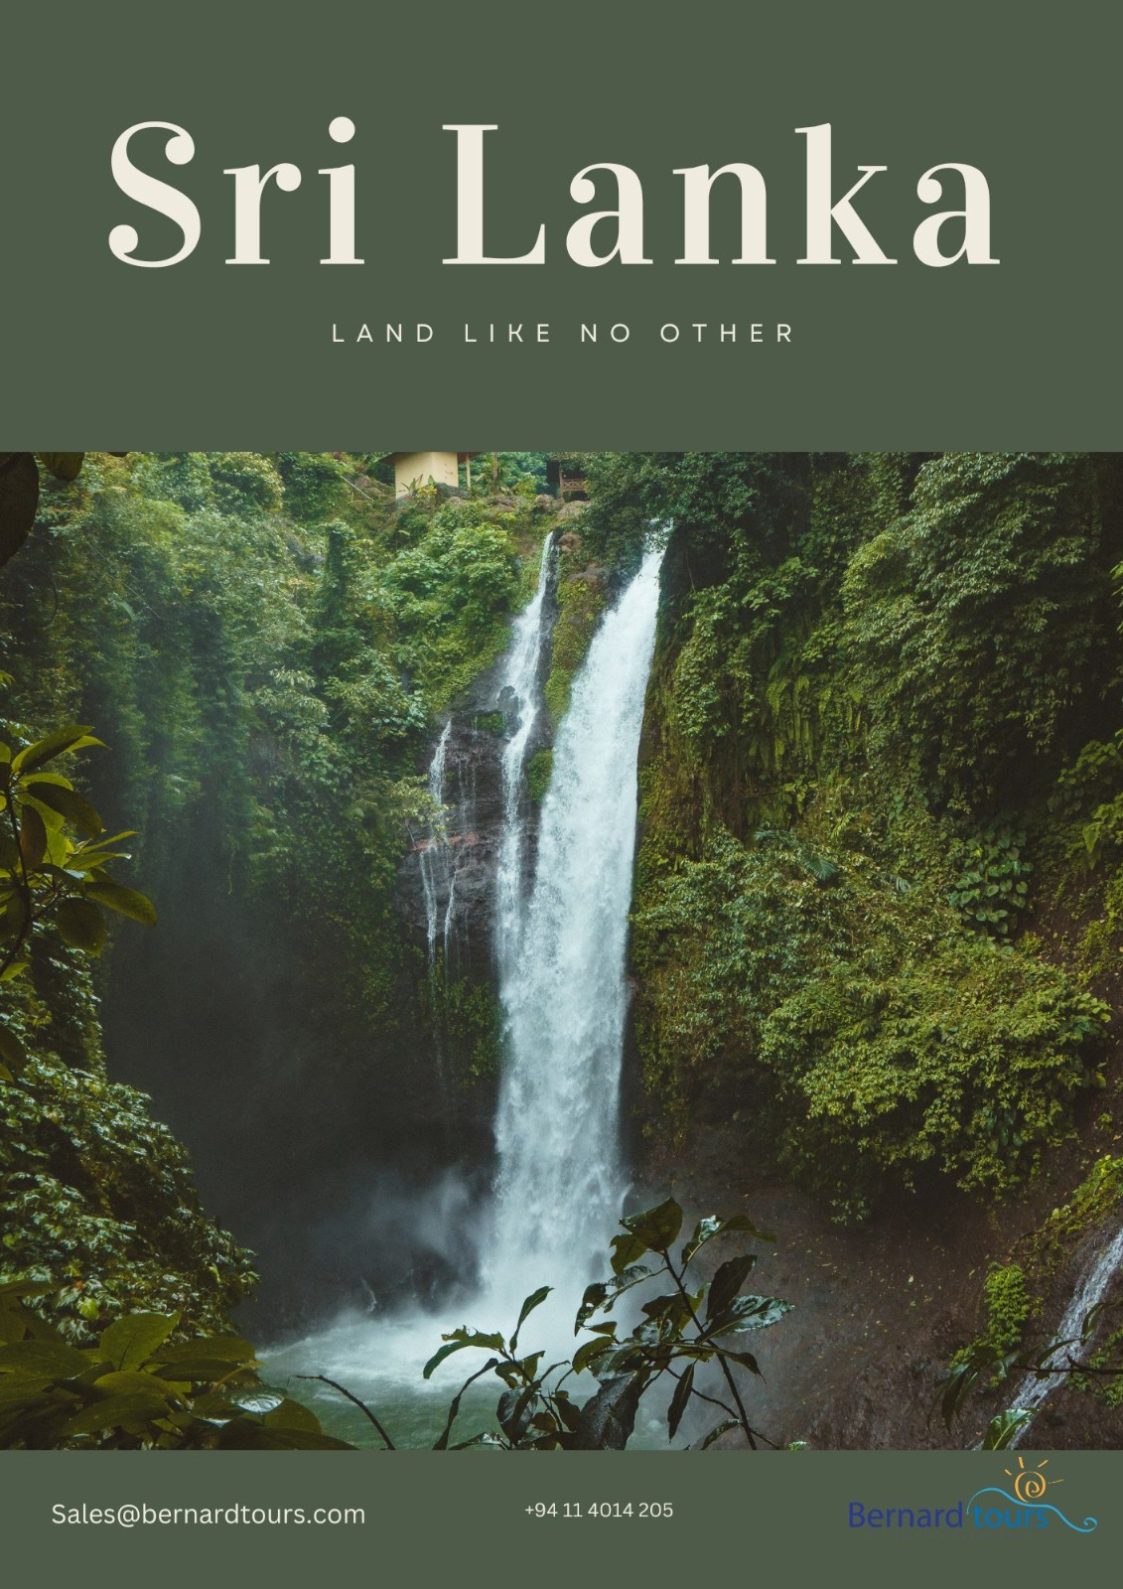

**WELCOME TO SRI LANKA.**

**(THE LAND OF PARADISE)**

**HISTORY**

The history of SRI LANKA begins around 30,000 years ago when the island was first inhabited. Chronicles including the Mahawansa, The Dipavamsa, the Culavamsa and the Rajaveliya record events from the beginning of the Sinhalese monarchy in the 06th century B.C. Through the arrival of European Colonialists in the 16th century, and to the disestablishment of the monarchy in 1815. Some mentions of the country are found in the RAMAYANA. Buddhism was introduced in the 03rd century B.C by Arhath Mahinda (son on the Indian emperor Ashoka the Great).

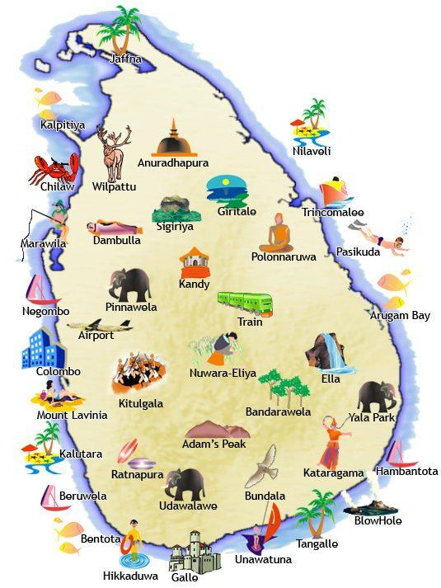**THE FACTS:**

* Population 21 million.
* 3 main languages - Sinhala,

Tamil and English.

* Buddhist majority (70%), with Hindu,

Christian and Muslim minorities.

* Gained independence from Britain in 1948.
* Democratic Socialist Republic since 1978.
* The top exports are: Tea, Textiles, Gems AND

Foreign Remittances.

**THE TRIVIA:**

* Has the highest concentration of

Leopard in the world.

* 7 of the world’s UN World Heritage Sites.
* Is one of the world’s 25 Biodiversity Hot Spots
* World’s 3rd largest tea producer.
* The Sinhalese name, Sri Lanka, means,

"The Resplendent Land" or "Holy Ceylon.”

* Is famous for its Ceylonese Sapphire
* Has 1,340km of tropical coastline.

**05 Nights / 06 Days – Discover Sri Lanka**

**DAY 01 – BIA – DAMBULLA**

When you arrive at the Bandaranaike International Airport, a representative of Bernard Tours will meet and greet you and drive you to **Dambulla**.

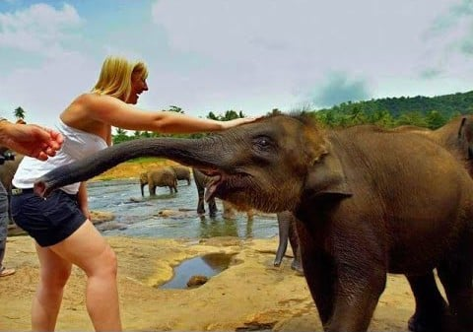**En-route visit Pinnawala Elephant orphanage.(Optional)**

The Pinnawala Elephant Orphanage is situated Northwest of the town of Kegalle, halfway between the present capital Colombo and the ancient royal residence Kandy in the hills of central Sri Lanka. It was established in 1975 by the Sri Lanka wildlife department on a 25-acre coconut property near the Maha Oya River. The orphanage was originally founded in order to afford care and protection to the many orphaned Elephants found in the jungle.

Checking the Hotel.

A leisurely evening at the hotel.

**DINNER AND OVERNIGHT STAY IN DAMBULLA**

**DAY 02 – SIGIRIYA**

After delicious breakfast drive towards **Sigiriya**

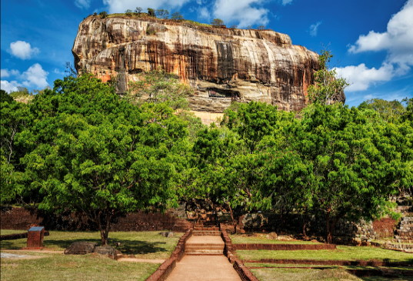**Sigiriya Rock (Optional)**

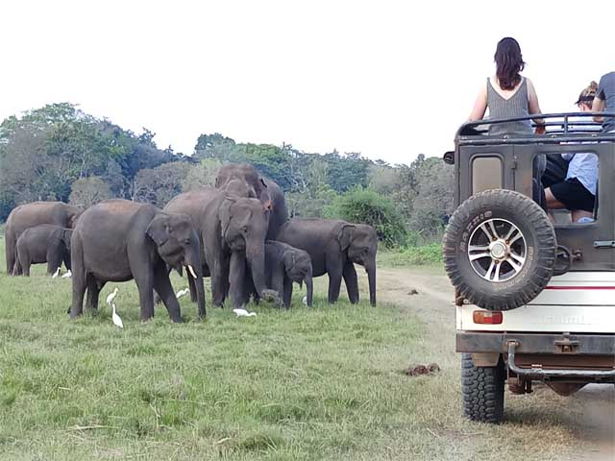Sigiriya is located in the northern Matale district near the town of Dambulla in central province of Sri Lanka. The word Sigiriya or the Sinhagiri means the Lion’s Rock where you have to climb up 1200 steps before you reach the Lion Rock Fortress on top of Sigiriya. There are several platforms that break up the steps and allow for a little break if you need it. Today Sigiriya rock fortress is one of the most famous Archeological Treasure and UNESCO named Sigiriya rock as a World Heritage in 1982 under the name “Ancient City of Sigiriya Sri Lanka”.

**Evening Minneriya National Park Safari (Optional)**

Minneriya National Park is home to the world’s largest known gathering of Asian elephants. During this period, herds of up to 350 elephants are seen at the 8,890-hectare park within a few square kilometers of the Minneriya Tank. According to some reports, there are as many as 700 elephants. Tourists visit Minneriya National Park largely because of elephants, especially in the dry season.

A leisurely evening at the hotel.

**DINNER AND OVERNIGHT STAY IN DAMBULLA**

**DAY 03 – DAMBULLA – KANDY**

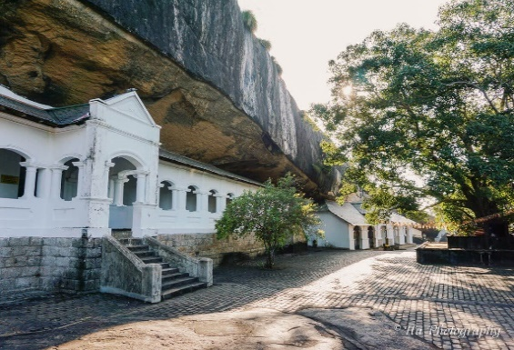After delicious breakfast visit **Dambulla Cave Temple**

**Dambulla Cave Temple (Entrance Fee not included)**

Located in central Sri Lanka, the Rangiri Dambulla Cave Temple is a living Buddhist site that is focused on a series of five cave shrines. Inhabited by forest-dwelling Buddhist monks since the 3rd century BCE, these natural caves have been transformed continuously throughout the historical period into one of the largest and most outstanding Buddhist complexes in the Southern and South Eastern Asian region, showcasing innovative approaches to interior layout and decoration.

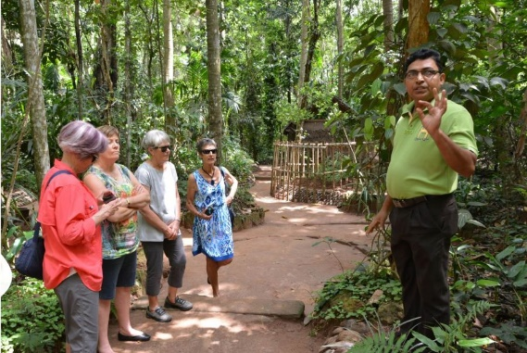**Matale Spice Garden.**

Just 25 km from the hill capital of Kandy, the Matale spice gardens are among the best on the island. You will be introduced to different spices and shown how some of these spices are grown and processed. A processing and training unit has been set up in the area and farmers are grouped in a cooperative to ensure fair prices and you will also be able to purchase spices. Gardens are open to visitors, a delightful place to stroll in fragrant greenery and learn about nutmeg, pepper vines, clove trees and curry, cinnamon and the precious cardamom, a relative of ginger. It grows in the shade of high jungle trees and can only be harvested by hand.

Afternoon drive towards **Kandy.**

**Kandy** is a large city in central Sri Lanka. It's set on a plateau surrounded by mountains, which are home to tea plantations and biodiverse rainforest. The city's heart is scenic Kandy Lake (Bogambara Lake), which is popular for strolling. Kandy is famed for sacred Buddhist sites, including the Temple of the Tooth (Sri Dalada Maligawa) shrine, celebrated with the grand Esala Perahera annual procession.

Checking the Hotel.

A leisurely evening at the hotel.

**DINNER AND OVERNIGHT STAY IN KANDY.**

**DAY 04 – KANDY**

After delicious breakfast **City Tour in Kandy.**

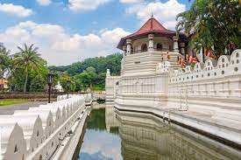**Temple of the Tooth Relic (Entrance Fee not Included)**

The Temple of the Sacred Tooth Relic is a world-renowned place of worship, where the left Canine tooth of Gautama Buddha is enshrined. The temple which is venerated by thousands of local & foreign devotees and tourists daily was named as a world heritage by UNESCO in 1988. The temple which carries a lot of value to Buddhists all over the world also has immense cultural value. The architecture is of unique Kandyan architectural style with a combination of the unique style used to build “Dalada Mandira” the shrines which housed the Sacred Tooth Relic previously in other kingdoms.

**Peradeniya Botanical Garden (Optional)**

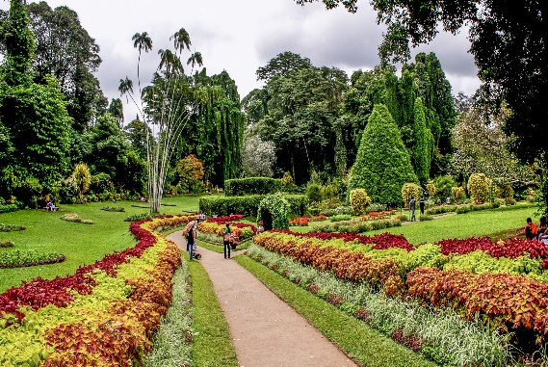Peradeniya Gardens is a spacious 147 acre of natural extravaganza consisting of more than 4000 species of plants, and 10,000 varied kinds of trees, incidentally serves as the largest garden of Sri Lanka. The unique and rarest collection in these gardens is the Giant Bamboo of Burma which grows 12 inches each day to a height of 40 meters. Apart from this other amazing collections include Javan fig tree, Cannonball tree, Double Coconut Palm and about 200 other varieties of palm trees and versatile collection of flora. The Peradeniya Botanical Garden is one prime tourist attraction of hill country and remains quite flooded with tourists every weekend.

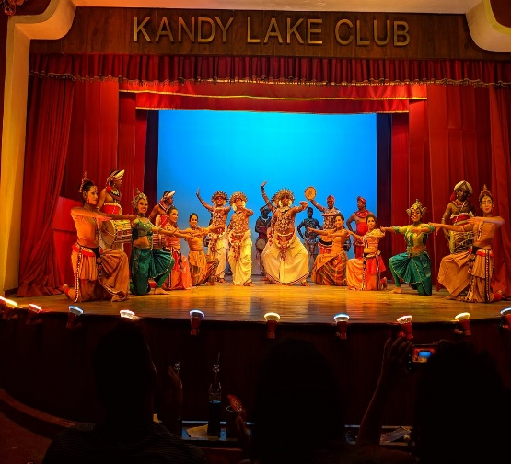**Evening Cultural Dance show.**

The Kandy Cultural Dance Show is a stimulating Sri Lankan Arts, Dance & Cultural Heritage Show that is a must see for any visitor who visits the historic city of Kandy. These Dances are performed at local ceremonies and rituals using drums and costumes that are unique to each area. Among the attractions are the Dances depicting the majestic walk of the elephant, colorful performance of the peacock and the mystical movements of the cobra.

A leisurely evening at the hotel.

**DINNER AND OVERNIGHT STAY IN KANDY.**

**DAY 05 – KANDY – COLOMBO**

After a delicious breakfast, drives towards **Colombo**

City tour of Colombo followed by shopping tour.

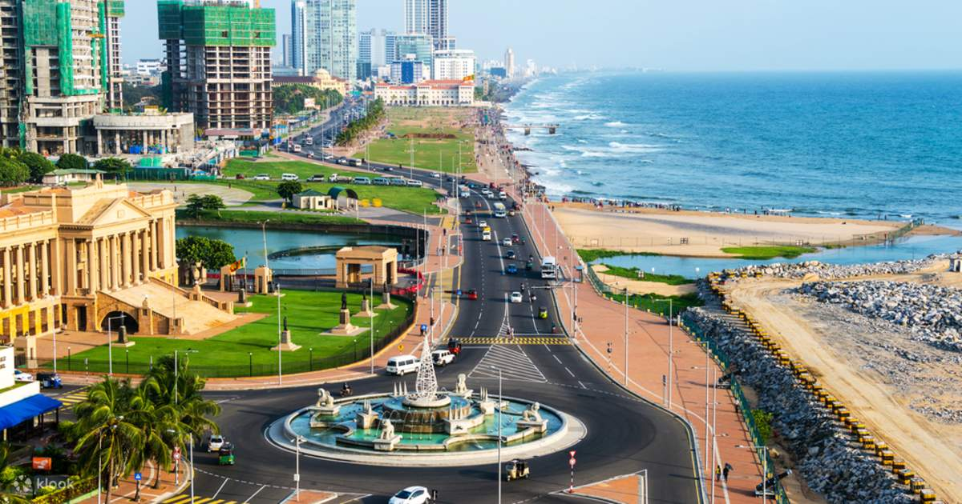Colombo – the trade and commercial capital has long been the traditional gateway to the Orient.  Sri Lanka’s largest city, it is located on the west coast and draws together all the cultures, religions, and influences of foreign lands into a potpourri of sounds, smells and a kaleidoscope of color. The original traders and settlers - the Arabs, Portuguese, Dutch and the British have left in their wake churches and monuments, names and religions, costumes and food and smatterings of their languages which have been absorbed into the speech of the Sri Lankan. Today, Colombo is a fascinating city - a happy blend of east & west, past & present, with a charm of its own.

A less known but amazingly true fact is that Colombo has a superb range of high-quality restaurants serving food from all over the world and some of the best shopping opportunities in Asia.

Checking the hotel

Explore Colombo nightlife on own.

**DINNER AND OVERNIGHT STAY IN COLOMBO**

**DAY 06 – COLOMBO – BIA**

Breakfast at the hotel.

As all the good things must come to end, our chauffeur guide will take you to the airport to catch the departure flight.

***END TOUR***

**Hotels Used: 5\***

**Travel Date: 01 Nov 2023 – 30th April 2024 (Except 20 Dec – 10 Jan 2024)**

|  |  |  |  |  |  |  |
| --- | --- | --- | --- | --- | --- | --- |
| NO OF NIGHTS | NAME OF THE HOTEL | Room Type | Meal Pan | | | LOCATION |
| 02 | Heritance Kandalama 5* | Superior | | HB | Kandalama | |
| 02 | Earl’s Regancy 5* | Deluxe | | HB | Kandy | |
| 01 | Courtyard By Marriott 5* | Superior | | HB | Colombo | |

**Price based on 02 pax traveling together:**

Price per person sharing a DBL/Twin room on HB basis = 685 US $

**Supplement Costs:**

|  |  |
| --- | --- |
| ENTRANCE FEE | RATES PER PERSON |
| Pinnawala Elephant Orphanage | US $ 18 net |
| Dambulla Cave Temple | US $ 10 net |
| Sigiriya Lions Rock | US $ 30 net |

**Value Additions from Bernard Tours**

* **Map of Sri Lanka**
* **Free Sim Card on request (Guest passport needed before arrival)**
* **Room upgrade on availability**
* **02 X 500 ML water bottle per person per day.**
* **Welcome at the airport with Garlands**
* **Express way charges wherever applicable.**

**The above rate includes:**

* Accommodation at the above mentioned hotels or similar
* Daily breakfast & dinner at the hotel
* Meet & Assist at the airport
* Half Day Kandy City Tour
* Half Day Colombo City Tour
* An air-conditioned vehicle with an English speaking driver throughout the tour
* All applicable Gov. Taxes

**The above rate excludes:**

* Airfare & VISA charges
* Entrance fees to any sites not mentioned above
* Tips & portages
* Any meals not mentioned above
* Any other services not mentioned above
* Early check in & Late check out