4 Days Murchison Falls Wildlife Safaris
Destination: | Murchison Falls National Park
Activities/Attractions: | Chimps Tracking, Game drives, Boat rides, Top of the Falls & Rhino tracking
Vehicle Type: | Toyota Land Cruiser

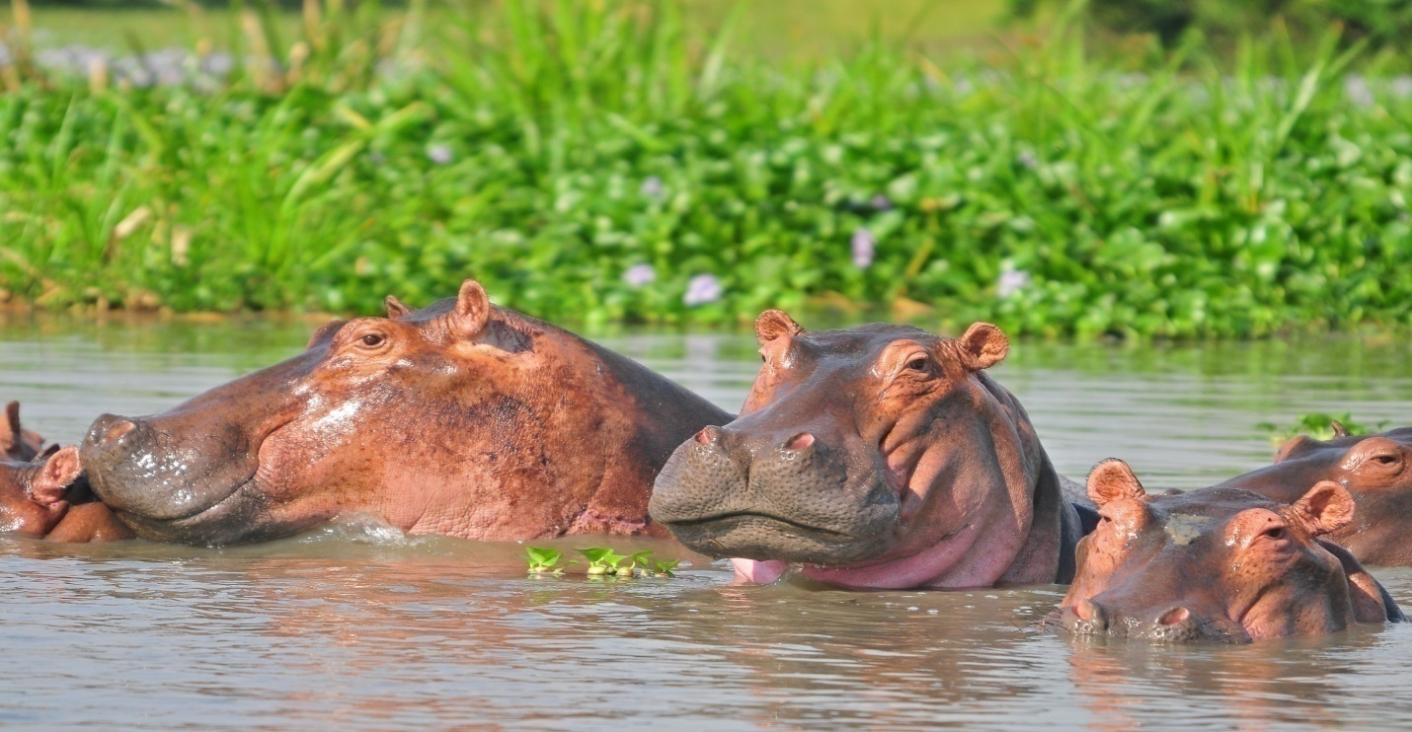

Pre Tour: Pickup and transfer to your lodge in Entebbe.
On arrival at Entebbe International Airport, you will be received by our Professional Driver Guide who will then take you through your safari itinerary and thereafter, transfer you to your hotel in Entebbe for an overnight stay.
Overnight: 2freinds Beach Hotel
Meal Plan: Dinner.

Day 1: Transfer to MFNP Incl. Ziwa Rhino Sanctuary

Description
Your safari will start at exactly 07:00 am. We will transfer you to Murchison Falls National park, northwest of Kampala.
But along the way, you will visit the Ziwa Rhino sanctuary in Nakasongola district near Nakitoma village along the Gulu–Kampala Highway. This sanctuary is home to wild endangered rhinos, and it covers approximately 7,000ha. Here, you will track rhinos on foot; and this is a great and exciting activity as it involves you watching them at a close and safer distance of about 7m with the guidance of game ranger.
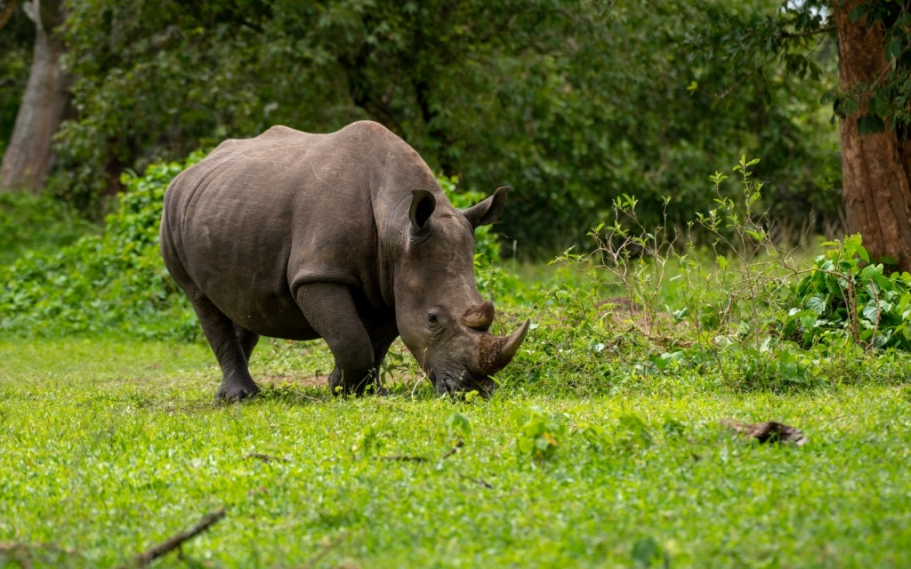
After tracking, you will then proceed to Murchison Falls National Park. Check in your lodge, relax, dine and have an overnight stay.
Overnight: Pakuba Safari Lodge https://pakubasafarilodge.com/
Meal Plan: Breakfast, Lunch, and dinner

Day 2: Morning game drive. Waterfalls and Sundowner Cruise

Description
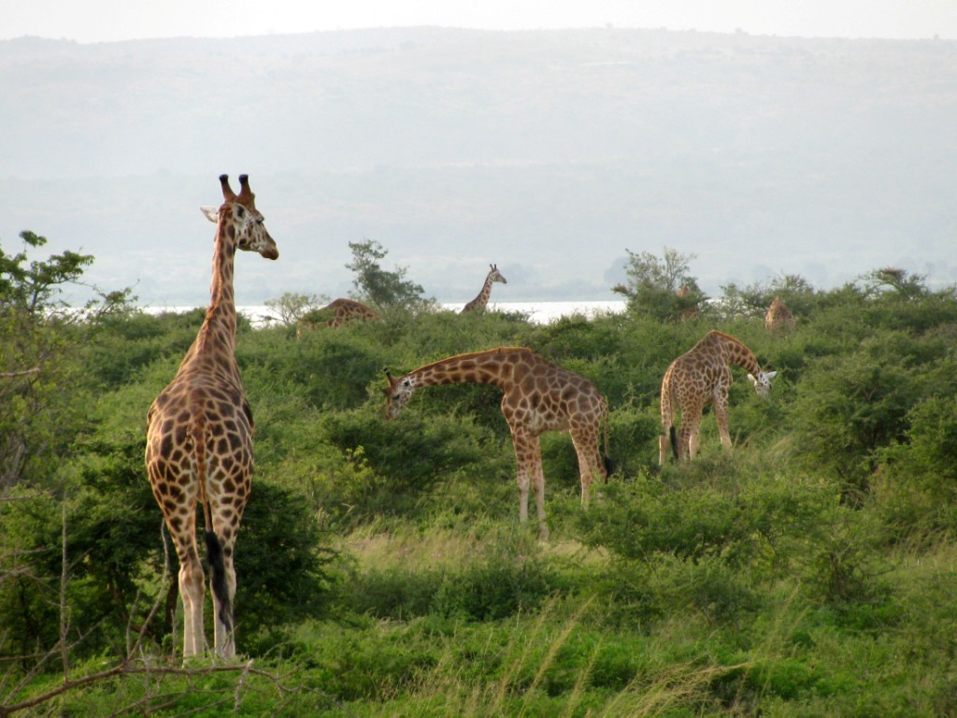
At 06:40 am after having your early morning breakfast, you will go for a game drive to catch a glance of the early risers and nocturnal animals going back to their hideouts. Following Victoria Nile and Buligi tracks through open savannah grassland, you will appreciate the rich diversity of wildlife in the Park-embowered in various eco-systems.
Wild games to encounter will include; elephants, buffaloes, Jackson's hartebeest, oribi, reedbuck, hyenas among others, and exclusive species like elusive shoebill stork, yellow fronted tinker birds, goliath heron, malachite, kingfisher, etc.
Come back to your lodge, relax, have lunch and later go for an evening waterfalls and Sundowner cruise. This is one of the most thrilling experiences nature offers. The cruise starts at around 3:00 pm, heading upstream towards the Nyamsika sandbar, as well as a visit to the delta point where the Victoria Nile meets the Albert Nile. The cruise comes with a variety of drinks and snacks like beers, sodas, bottled water, champagne, meatballs, cheese, nachos, and peanuts to mention but a few. When you begin your sundowner cruise heading to the waterfalls, the river banks at this time of the day are teaming with lots of wildlife including; hippos, elephants, crocodiles, bushbucks, buffalos, and a wide variety of birds which your boat skipper will point out to you. The boat cruise lasts for about 3 hours.
Return, dine, and have an overnight stay.
Overnight: Pakuba Safari Lodge https://pakubasafarilodge.com/
Meal Plan: Breakfast, lunch, and dinner

Day 3: Morning delta Cruise. Afternoon Chimps Tracking

Description
At exactly 06:00 am after having your early morning breakfast, you will be driven to WF Jetty for your Delta cruise launching from Paraa at 07:00 am and sailing downstream gently on the flowing Nile waters meeting many floating papyrus islands, it's here, the Albert Nile, that you have an excellent opportunity for viewing extensive birdlife including the pre-historic shoebill, cliff nested red throat bee-eaters, hippos and crocodiles along the way.
Optional Packed Breakfast on board available @ $12 each, Buffet Breakfast @ $15 each. Advance booking required*
Retire, relax and have lunch at your lodge.
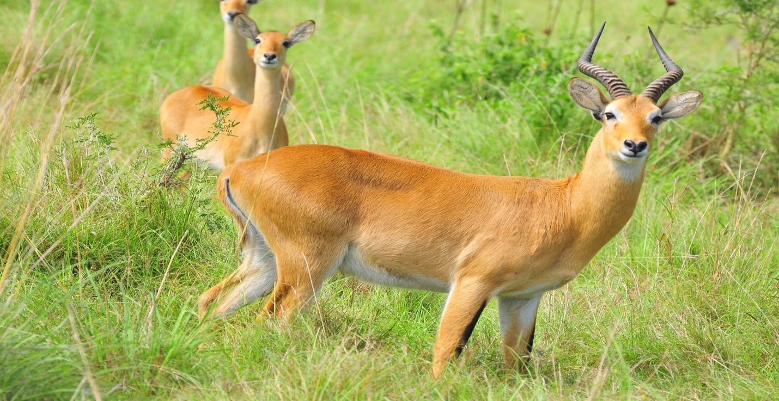
Later in the afternoon, you will go for Chimpanzee tracking experience in the Budongo forest. Upon your arrival at Pabidi, you will be briefed on the Dos and Don’ts by the ranger guides who are skilled and knowledgeable about the chimps and other primates. During this activity, you will also be able to see other primates include Olive baboons, Blue Monkeys, Black-and-White Colobus Monkeys, Red-tailed Monkeys, Grey-cheeked, Mangabeys and Blue Monkeys. Budongo forest reserve is also a birders paradise. Over 355 species can be found here and include African Emerald Cuckoo, African Pied, African Shrike Flycatcher, Black and White Casqued Hornbills, Black-headed Paradise Flycatcher, Blue-throated Roller, Brown Twinspot, Cameroon Sombre Greenbul, Cassin’s Hawk Eagle, Cassin’s Honeyguide, Cassin’s Spinetail, Chestnut Crowned Eremomera, Chestnut-capped Flycatcher, Chocolate.
Get back to your lodge, dine and have an overnight stay.
Overnight: Pakuba Safari Lodge https://pakubasafarilodge.com/
Meal Plan: Breakfast, Lunch, and Dinner

Friday, 15 July 22: Morning Top the falls Hike. Afternoon transfer to Entebbe
Description
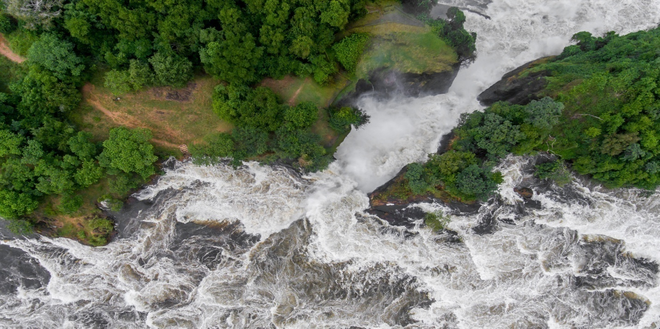
After your early morning breakfast, you will be driven to the Top of the falls. This is a two-in-one activity for you to get the best time watching the birds and also enjoy the spectacular view of the Nile and the landscape of the park.
Withdraw and transfer back to Entebbe following Masindi- Kampala Highway.

Overnight: -
Meal plan: Breakfast, lunch en-route,-
END OF SAFARI
Price Per Person
2Pax: $ 1,659 Per Person
The price is based on two people sharing a room. A single room surcharge applies for clients who would like to stay in single rooms.
Inclusions
- All Park fees
- All activities mentioned in the itinerary.
- Full board accommodation in property mentioned in the itinerary.
- All meals stated in the itinerary unless clearly marked as optional.
- A professional and experienced English-speaking driver/tour guide.
- All transportation in a 4x4 safari vehicle, including fuel.
- All Taxes/VAT
- Mineral water on the way.
Exclusions
- Additional accommodation after the tour.
- Accommodation upgrade
- Tips, souvenirs, personal purchases, travel insurance and visa fees.
- Other soft drinks or premium soft drinks and extra meals

