3 DAYS GORILLA TRACKING
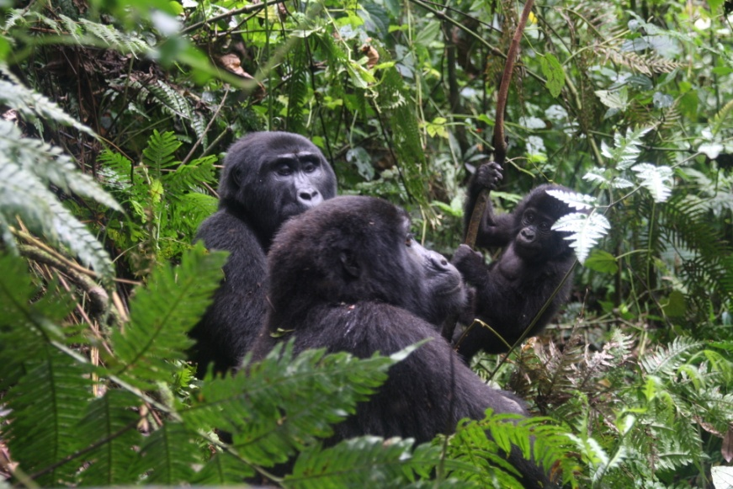
Overview
The 3 Days Uganda Gorilla Safari takes you to the gorilla trekking in Bwindi Impenetrable National Park where almost a half of the world’s endangered mountain gorillas are currently thriving. With over 400 mountain gorillas distributed in four different regions of Buhoma, Ruhija, Rushaga and Nkuringo, passing through steep hill sides, narrow valleys and bamboo shoots, etc.
Safari highlights
Day 1: Drive to Bwindi forest
Day 2: Gorilla Tracking:
Day 3: Return to Kampala via Equator

Day 1: Drive to Bwindi forest
Your driver will pick you up from the airport, lodge, and hotel or at your place of stay within Kampala. You will then drive to Bwindi in the south-western part of Uganda .passing through a memorable part of the country referred to as “the Switzerland of Africa”, Due to its physical appearance with hilly landscape, covered with cultivated terraces by the “bakiga people”, tropical rain forests and lakes (mostly craters) which is good for viewing. You will stop at a local restaurant on the way. After your lunch you will then continue with your journey, and you will reach late in the afternoon spending you night at the booked lodge
Driving time: 8 hours
Accommodations
Budget: Gorilla Valley lodge
Meal plan: Bed breakfast
Day 2: Gorilla Tracking:
Bwindi Impenetrable Forest favors both mountain gorillas and some chimpanzees one of the only forest in Africa which posses these creatures. It also hosts five other species of primate, 100 mammals, around 78 butterflies and 360 bird species.
In the early morning after your breakfast, your driver will transfer you to the starting point of your tracking group or UWA headquarters to be briefed at (7.45am or 8.30am), then you will start the tracking. The gorillas that you track are very friendly to people, though still there are same groups which are shy, sharp and stubborn as human beings. Your experienced ranger will help you to spot out their presence. You will be going through the bush, as are push your way through the undergrowth, parting thick creepers, to track the gorillas
Once you find the gorillas, you will spend with them up to one hour which is given time, before going back to your lodge.
Note: (This trek can take from half an hour to 5 hours depending on the area you track and group– a reasonable degree of fitness is required as well as a sturdy pair of walking shoes). Have your Dinner and overnight at:
Accommodations
Budget: Gorilla valley lodge
Meal plan: - Bed & breakfast

Day 3: Return to Kampala via Equator
In the morningafter taking breakfast, you will then drive back to Kampala having a stopover at the Equator take photos shoots and buying souvenirs. You will be then taken to your guesthouse, lodge or hotel of your choice in Kampala or Entebbe and also we can drop you to the airport to catch your flight back to your home country.
Driving time: 7 to 8 hour

Accommodation for tonight is not included in the program. If you want us to book an extra night/day room for refreshment in Kampala or Entebbe, please you can inform us in advance so that you can even have a little leisure time and relax around Entebbe or Kampala.
OF THE SAFARI
NOTE: For the above-mentioned accommodation it depends on availability, and we make sure the best is our first priorities when we are making this booking. When there is no availability during the requested dates of your safari, we do our best to look for another alternative accommodation which is relatively or in the same rate/price range.
The package includes:
- Ground transportation by 4WD land cruiser/minivan
- Airport drop off
- Accommodation per program
- Meals (Bed & Breakfast) as itinerary
- English speaking Driver/Guide
- Fuel
- water
- 1 gorilla permit per person
- Rangers fees
The package excludes any cost of personal nature like:
- Tips
- Laundry
- Souvenirs
- Personal drinks and cigarettes
- International Air ticket and related costs
- Personal Insurance covers
- Meals out of booked accommodations and program
- Optional activities
- Phone calls
Rates

1 pax | $1,558
2 pax | $1,170
3 pax | $1,053
4 pax | $1,024
5 pax | $983
6 pax | $975

1 Triple

1 Triple, 1 single
Book your safari now!

