7 Days Machame route: Africa Natural Tours & Safari
AFRICA NATURAL TOURS & SAFARI (The best tour company in Tanzania)
Specialized in: Wildlife safaris, Cultural tourism, Mountain climbing and Beach holidays
Contact +255 764415889

Email-info@africanaturaltours.com
www.africanaturaltours.com
The seven day Machame variation is the ideal schedule for this route. On the 7 day Machame route, the trek from Barranco to Barafu is broken up into two days, allowing for a short day just prior to the summit attempt. This is important because summit day begins very early, around midnight, so climbers are sleeping deprived going into the toughest day on the mountain. By having a short day beforehand, climbers can be better rested. The 7 day Machame route is highly recommended and used by most prominent Kilimanjaro operators.
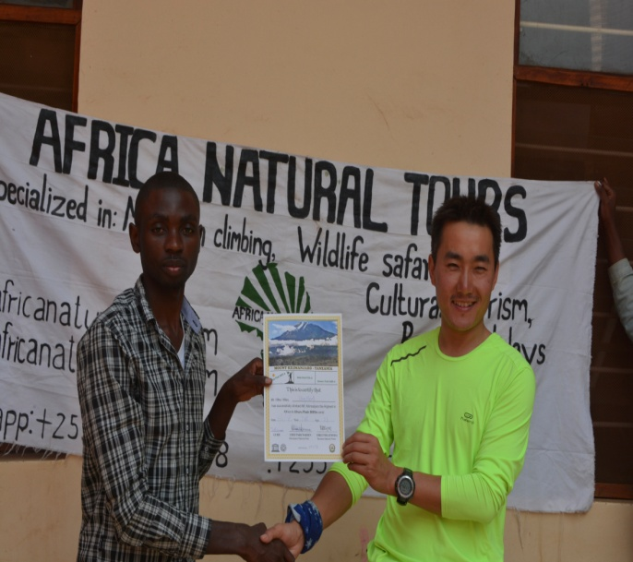

Day 0: Arrive at the Kilimanjaro International Airport

Arrive at the Kilimanjaro International Airport where you will be meet with Africa Natural Tours driver at the airport and be transferred to the hotel in Moshi for overnight.

Day 1: Machame Gate to Machame Camp
Elevation (ft): 5,400ft to 9,400ft, Distance: 11 km, Hiking Time: 5-7 hours, Habitat: Rain Forest
We will drive from Moshi/ Arusha to the Mount Kilimanjaro National Park Gate takes about 50 minutes. The journey passes through the village of Machame which is located on the lower slopes of the mountain. We now leave the park gate and walk through the rain forest on a winding trail up a ridge. Lower down, the trail can be muddy and slippery. Gaiters and trekking poles are a good idea here. We continue a short distance until we reach the Machame Camp.
Day 2: Machame Camp to Shira Camp
Elevation (ft): 9,400ft to 12,500ft, Distance: 5 km, Hiking Time: 4-6 hours, Habitat: Moorland
After breakfast, we leave the glades of the rain forest and continue on an ascending path, crossing the little valley walking along a steep rocky ridge, covered with heather, until the ridge ends. The route now turns west onto a river gorge. Time for rest, dinner, and overnight at the Shira campsite.
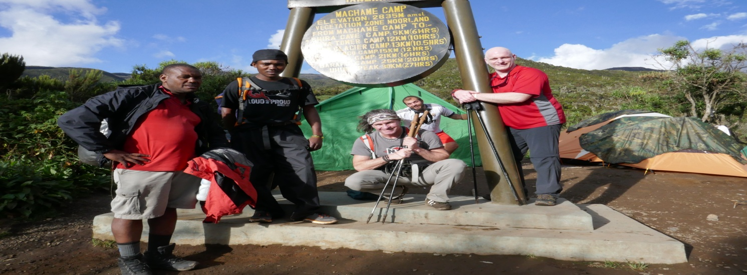
Day 3: Shira Camp to Lava Tower to Barranco Camp
Elevation (ft): 12,500ft to 13,000ft, Distance: 10 km, Hiking Time: 6-8 hours, Habitat: Semi Desert
From the Shira Plateau, we continue to the east up a ridge, passing the junction towards the peak of Kibo. As we continue, our direction changes to the South East towards the Lava Tower, called the "Shark's Tooth." Shortly after the tower, we come to the second junction which brings us up to the Arrow Glacier at an altitude of 16,000ft. We now continue down to the Barranco Hut at an altitude of 13,000ft. Here we rest, enjoy dinner, and overnight. Although you end the day at the same elevation as when you started, this day is very important for acclimatization and will help your body prepare for summit day.
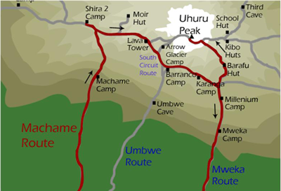
Day 4: Barranco Camp to Karanga Camp
Elevation (ft): 13,000ft to 13,100ft, Distance: 5 km, Hiking Time: 4-5 hours, Habitat: Alpine Desert
After breakfast, we leave Barranco and continue on a steep ridge passing the Barranco Wall, to the Karanga Valley campsite. This is a short day meant for acclimatization.
Day 5: Karanga Camp to Barafu Camp
Elevation (ft): 13,100ft to 15,300ft, Distance: 4 km, Hiking Time: 4-5 hours, Habitat: Alpine Desert
After breakfast, we leave Karanga and hit the junction which connects with the Mweka Trail. We continue up to the Barafu Hut. At this point, you have completed the South Circuit, which offers views of the summit from many different angles. Here we make camp, rest, enjoy dinner, and prepare for the summit day. The two peaks of Mawenzi and Kibo are to be seen from this position.
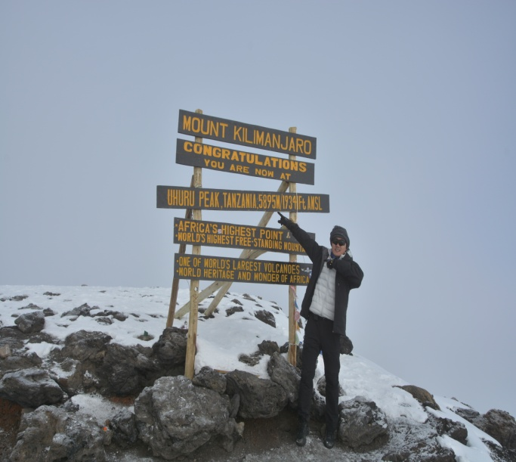
Day 6: Barafu Camp to Summit to Mweka Hut
Elevation (ft): 15,300ft to 1345ft (and down to 10,000ft) ,Distance: 5 km… ascent / 12 km descent ,Hiking Time: 7-8 hours ascent / 4-6 hours descent ,Habitat:
Very early in the morning (midnight to 2am), we continue our way to the summit between the Rebmann and Ratzel glaciers. You head in a northwesterly direction and ascend through heavy scree towards Stella Point on the crater rim. This is the most mentally and physically challenging portion of the trek.At Stella Point (18,600 ft), you will stop for a short rest and will be rewarded with the most magnificent sunrise you are ever likely to see (weather permitting). From Stella Point, you may encounter snow all the way on your 1-hour ascent to the summit. At Uhuru Peak, you have reached the highest point on Mount Kilimanjaro and the continent of Africa. Faster hikers will see the sunrise from the summit. From the summit, we now make our descent continuing straight down to the Mweka Hut camp site, stopping at Barafu for lunch. You will want gaiters and trekking poles for the loose gravel going down. Mweka Camp is situated in the upper forest and mist or rain can be expected in the late afternoon. Later in the evening, we enjoy our last dinner on the mountain and a well-earned sleep.
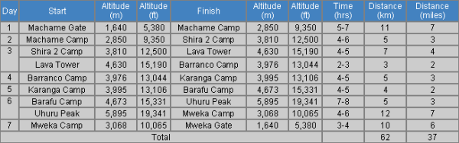
Day 7: Mweka Camp to Moshi
Elevation (ft): 10,000ft to 5,400ft, Distance: 10 km, Hiking Time: 3-4 hours, Habitat: Rain Forest
After breakfast, we continue the descent down to the Mweka Park Gate to receive your summit certificates. At lower elevations, it can be wet and muddy. Gaiters and trekking poles will help. Shorts and t-shirts will probably be plenty to wear (keep rain gear and warmer clothing handy).From the gate, you continue to drive you back to Moshi

Day of departure: Transfer to the Kilimanjaro Airport.

Included.
  - Park fees,
  - Camping fees
  - Rescue fees
  - 18% VAT on tour fees & services which cost nearly 55% of the total cost charged.
  - Transportation to & from the mountain gate
  - Professional mountain guides, cooks and porters
  - 3 meals daily while on the mountain
  - Filtered water throughout the trek
  - Fair wages for the mountain crew as approved by the Kilimanjaro National Park Authority (KINAPA), Kilimanjaro Association of Tour Operators (KIATO)
  - Pick up and drop off to Kilimanjaro International Airport.
  - Pre and after Trek accommodations at the hotel, 2 nights at hotel in Moshi town with bed & breakfast (BB) Meal plan

Not Included
  - Both National and International flights
  - Medical insurance
  - Visa cost which is $50 except for Canadian and USA passport holders which is 100$
  - Tips to mountain crew
  - Items of a personal nature
  - Laundry Services
  - A doctor for the group
  - Alcoholic beverages
  - Portable flush toilet with a toilet tent is extra ($100 per toilet + toilet tent)
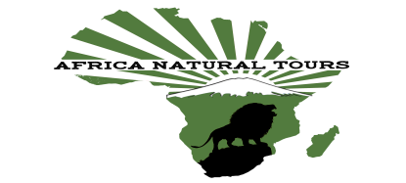
For more information visit www.africanaturaltours.com

