5 Days Marangu route: Africa Natural Tours & Safari
AFRICA NATURAL TOURS & SAFARI (The best tour company in Tanzania)
Specialized in: Wildlife safaris, Cultural tourism, Mountain climbing and Beach holidays
Contact +255 764415889

Email-info@africanaturaltours.com
www.africanaturaltours.com

About marangu route

Marangu Route has been referred to as the 'Coca Cola' route and this has led potential climbers to think that it is an easy route to the summit. This is far from the truth to be honest! The fact that it requires a minimum of 5 days to complete does not mean it is easier than any other route. The trail goes through lush rainforest, heath and moorland to alpine desert and ultimately the arctic zone at the peak and same route down. This safari is a great chance for you who is up for a Kilimanjaro adventure!

Day 0: Arrive at the Kilimanjaro International Airport

Arrive at the Kilimanjaro International Airport where you will be meet with Africa Natural Tours driver at the airport and be transferred to the hotel in Moshi for overnight.

Day 1: Marangu Gate to Mandara Hut.
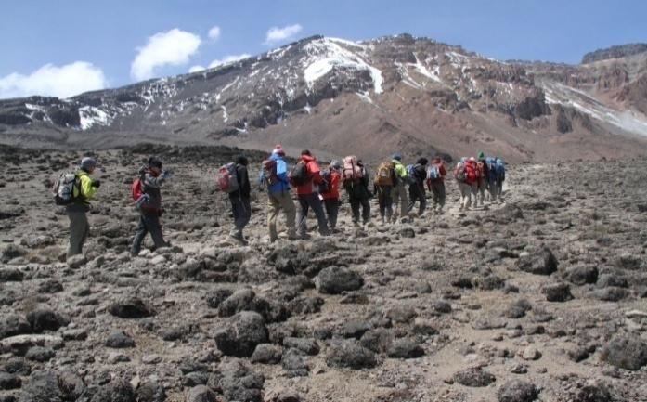

Take a short drive from Moshi town to the Kilimanjaro Park Gate (1,830 m.) lies at the edge of Marangu, which is an attractive village with many small coffee and banana plantations. After completing the entrance formalities, we climb up through attractive and unspoiled forest to reach the clearing containing Mandara Hut (2,700 m.). The volcanic remains of Maundi Crater are nearby, and make a good afternoon excursion. An alternative is to rest and enjoy the beautiful forest. There is a rich birdlife at the huts and monkeys are often seen as well. [3-5 hours walking to Mandara Hut]
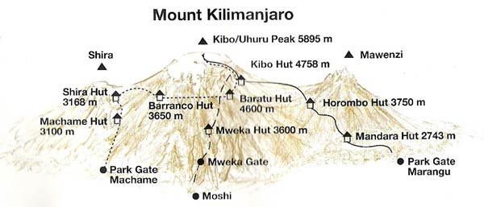
Day 2: Mandara Hut to Horombo Hut
The first part of the walk is a steep ascent through forest, but the path soon opens out into grassy moorland and, in clear weather, there are good views of Kibo and Mawenzi peaks. We climb steadily through the moorland zone, containing giant heather and occasional stands of groundsel, to eventually reach Horombo Hut (3,720 m.). Sunrises and sunsets here are often very stunning, the site is close to the glaciated dome of Kibo, and there is a real sense of being above the clouds. [4-6 hours walking from Mandara Hut to Horombo Hut]
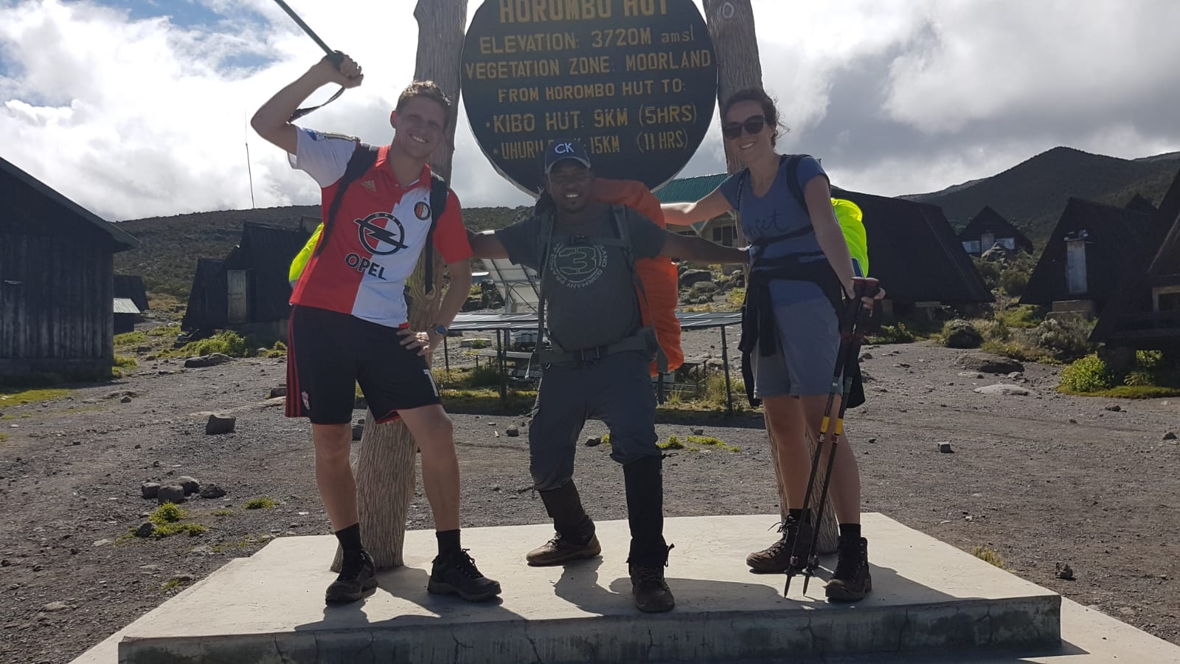
Day 3: Horombo Hut to Kibo Hut
We climb very gradually towards the lunar desert of the Saddle between Mawenzi and Kibo. The terrain changes to screed and there is a palpable sense of high altitude wilderness. We usually reach Kibo Hut (4,700 m.) at the bottom of the crater wall by midday and the afternoon is free (to contemplate the summit ascent!!). The remainder of the day is spent resting and eating in preparation for the final climb before a very early night! [4-5 hours walking from Horombo Hut to Kibo Hut]
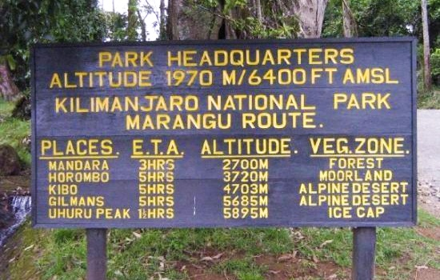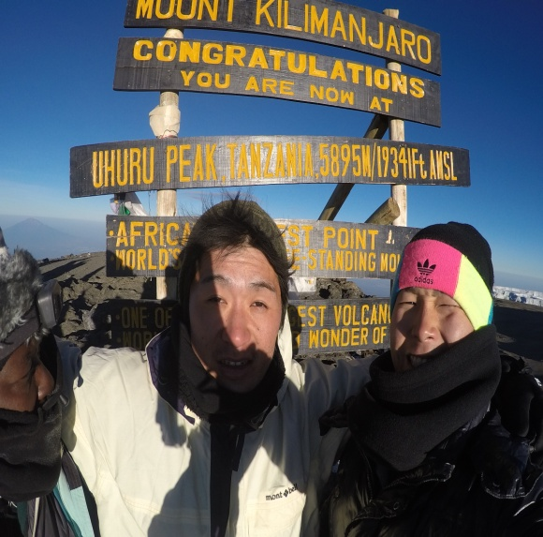
Day 4: Summit Day then down to Horombo Hut
We will start our ascent by torchlight at about 1 a.m. so that we can be up at Gillman’s Point by sunrise. The initial climb is steep over loose volcanic screen, but there are some well-graded zigzag and a slow but steady pace will have us up to Gillman’s (5,685 m.) in about five or six hours. We will rest there and spend some time taking in the sunrise. Those who are still feeling strong can make the three hour round trip from here along the crater rim to Uhuru Peak (5,896 m.) passing close to the spectacular glaciers that still occupy most of the summit area. The descent is surprisingly fast and we return to Horombo Hut for the night. [11-15 hours walking from Kibo Hut to Gillman’s Point]

Day 5: Horombo Hut – Moshi
After breakfast, we will start with a pleasant moorland walk to Mandara and then a lovely forest walk to the National Park gates to Moshi town at the hotel where you will overnight (BB)
The greenness and lushness of the forest is quite a stunning contrast to the summit day, and it really makes you realize how varied the scenery on Kilimanjaro really is. [5-6 hours walking

Day of departure: Transfer to the Kilimanjaro Airport.

Included
  - Park fees,
  - Hut fees
  - Rescue fees
  - 18% VAT on tour fees & services which cost nearly 55% of the total cost charged.
  - Transportation to & from the mountain gate
  - Professional mountain guides, cooks and porters
  - 3 meals daily while on the mountain
  - Filtered water throughout the trek
  - Fair wages for the mountain crew as approved by the Kilimanjaro National Park Authority (KINAPA), Kilimanjaro Association of Tour Operators (KIATO)
  - Pick up and drop off to Kilimanjaro International Airport.
  - Pre and after Trek accommodations at the hotel, 2 nights at hotel in Moshi town with bed & breakfast (BB) Meal plan

Not Included
  - Both National and International flights
  - Medical insurance
  - Visa cost which is $50 except for Canadian and USA passport holders which is 100$
  - Tips to mountain crew
  - Items of a personal nature
  - Laundry Services
  - A doctor for the group
  - Alcoholic beverages
  - Portable flush toilet with a toilet tent is extra ($100 per toilet + toilet tent)
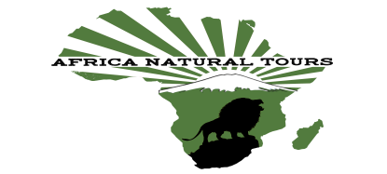
For more information visit www.africanaturaltours.com

