Ngorongoro Crater: Africa Natural Tours & Safari
AFRICA NATURAL TOURS & SAFARI (The best tour company in Tanzania)
Specialized in: Wildlife safaris, Cultural tourism, Mountain climbing and Beach holidays
Contact +255 764415889

Email-info@africanaturaltours.com
www.africanaturaltours.com

Day trip - Ngorongoro Crater
After an early morning breakfast in your hotel, we will come to pick you and we will start travel from Arusha to Ngorongoro Crater, as it is the best time to spot animals. On this day, we will enjoy a game drive around the crater and stop for a picnic lunch at a small lake within the park. The lake is home to many hippos and migratory birds, so guests will be sure to enjoy the visit! Due to the animal “oasis” created within the crater, there is a high possibility of spotting every member of ‘The Big 5’. The group comprises some of the strongest animals in Africa – the ferocious lion, the giant elephant, the stealthy leopard, the charging rhino and the mighty water buffalo. Ngorongoro Crater is truly an amazing place. Did you know it was formed over two million of years ago? A large volcano erupted, collapsing the volcano, but left a perfectly unbroken crater, known as a caldera. Within the amazing crater you can expect to view the playful zebra, lumbering hippo, swift wildebeest and cackling hyenas. In addition, there are flocks of graceful flamingos along the Soda Lake, while hungry hawks and vultures circle the sky in search their next meal of discarded carcass. Beautiful storks, ibis, and cranes are popular water birds in the crater, a sight not to miss. After a lovely afternoon of animal sightings, we will finally start our journey back to Arusha.

Package Includes
- Transport (4x4 Land Cruiser) with open roof
- Park fees
- Professional English speaking safari guide
- Lunches boxes
- 1,5 bottle of water

Not Included
- Flights (International & Domestics)
- Travel insurance
- Visa and passport fees
- Personal items
- Tips for safari guide & chef
- Soda and Alcoholic beverages
- Extra activities (Balloon flight $600 per person & Masai Village $ 45 per person)
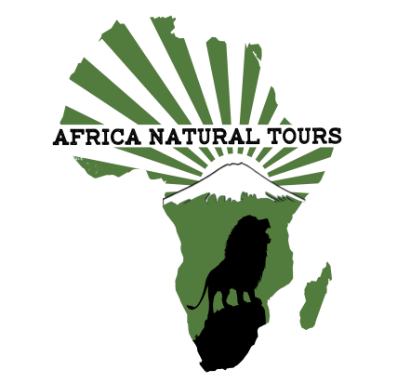
For more information visit www.africanaturaltours.com

