Arusha National Park Day Trip: Africa Natural Tours
AFRICA NATURAL TOURS (The best tour company in Tanzania)
Specialized in: Wildlife safaris, Cultural tourism, Beach holiday sand
Mountain climbing
Contact +255 764415889

Email-info@africanaturaltours.com

www.africanaturaltours.com

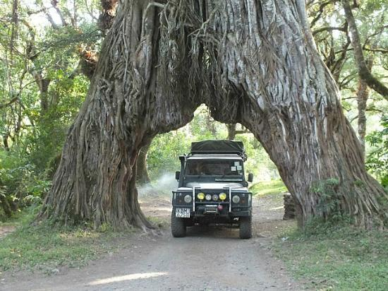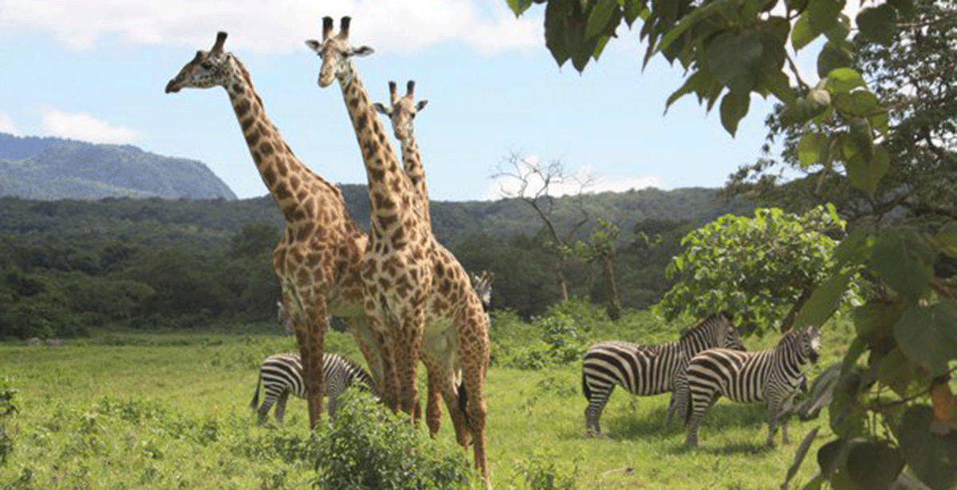

A Forgotten Pearl

Near the city of Arusha and the Kenyan border lies another scenic highlight of Tanzania, Arusha National Park. Its heart is the 4566 meter high Mount Meru, which is a popular destination for mountaineers. The park has an incredible variety of flora and fauna, which cannot fail to impress. Hollywood also chose this park.

Day Trip in Arusha National Park.
In the morning we leave from Arusha at 8:00 am to Arusha National Park gate takes approximately 1 hour. From here you will participate in a half day walking safari and a half day game drive. You will be accompanied by an armed ranger for the walk, who will guide you through the forest up to the waterfall and the point for viewing the black and white colobus monkeys. During the game drive you will see the Lakes of Momella and the Ngurduto Crater. You will spot buffaloes, waterbucks, giraffes, warthogs, zebras and gazelles as well as different bird species. You might also see a leopard or elephants, the elephants and leopards are though a shier than the ones in Serengeti. We game drive in the park till afternoon and then drive back to Arusha.

Our Package Includes
- Transport (4x4 Land Cruiser) with open roof
- Park fees
- Professional English speaking safari guide
- Lunch box
- 1,5l bottle of water

Not Included
- Flights (International & Domestics)
- Personal items
- Gratuities / "tip" for safari guide

ABOUT OUR SAFARI VEHICLES
- It owned by Africa Natural Tours & Safaris Company Limited
- Want NO mileage or fuel limits
- High maintenance standards, we have our own maintenance shop.
- Both of our Safari Cars are New
- All of our cars are 4x4 with pop-top roofs
- All of our cars have refrigerator
- All of our safari cars have camera charging ports.
- Most of our Cars are air conditioned
- We provide Water during Safari.

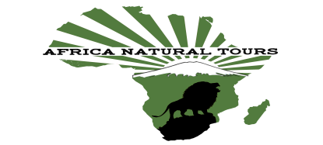
For more information visit www.africanaturaltours.com

